

PROJECT REPORT

HCL Electronic Shop
Semester: | Programming Fundamentals
Class: | PF1124
Group: | HCL
Instructor | Nguyen Dinh Cuong
Team members: | Nguyen Hai Long  Pham Nam Cuong  Pham Ngoc Huy

Index
HCL Electronic Shop 1
Index 2
I. Project introduction 3
II. Analyze System Requirements 4
III. Design Details 53
IV. Test 86
V. Task Assign (to each team member) 99
VI. Installation Instructions 100
Appendix 103

Project introduction
The system will provide these following features:
- Register/Login system:
  - Multiple user cases (Customer, Admin, Super Admin which each will have their own option menus).
- General product & functions:
  - View Product/Category information list function
  - Search for Product/Category functions.
- Shopping cart & placing order functions
  - Adding & removing Products to or from Shopping Cart to place Order
  - View Shopping Cart functions for all roles/user cases.
  - Complete & place order, cancelling order for all user cases.
  - Picking payment methods & checking out.
  - Checking Order details & status function for every user cases.
- Management functions:
  - Adding/removing/editing Product functions for Admin & Super Admin.
  - Adding/removing/editing Category functions for Admin & Super Admin.
  - Adding/removing/editing Customer functions for Admin & Super Admin.
  - Adding/removing/editing Admin functions for Super Admin.
- Proposed System
- To create a fully functional console app with database for digital marketing.
- Have multiple user cases and different permissions for each user roles: customers, staffs and managers.
- The scope of the project to be applied
- Made to be implemented into any kind of shops and stores.
- System Name
Electronic Shop
- Deployment environment
Window, Mac, Linux
- Development Tools
- Visual Studio Code
- Draw.io Diagram
- My SQL Workbench
- Customer Requirements (System features)
- You must login to use the system.
- You must have your account role set to be Admin or Super Admin to use their menu functions.
- You must have your address, phone number and payment method information to place an order.
- You must contact Admins or Super Admins in order to change your Customer information details.

Analyze System Requirements
This application project was created to help with managing digital marketing business models, it helps to improve management efficiency. Staffs and customers have easy access to products informations, which include price, name, product details or even it’s status, they can also easily place in any order with the shopping cart function. The main function of this system is for management, it helps the business with managing their products, orders as well as customers or even employees. Staffs can also create new user account for their customers or place in any order according to the customer’s request, allow them to view the information of unpaid orders and confirm successful payment if enough money has been received from the customers as well as canceling the order if necessary.
1.1 Use Case
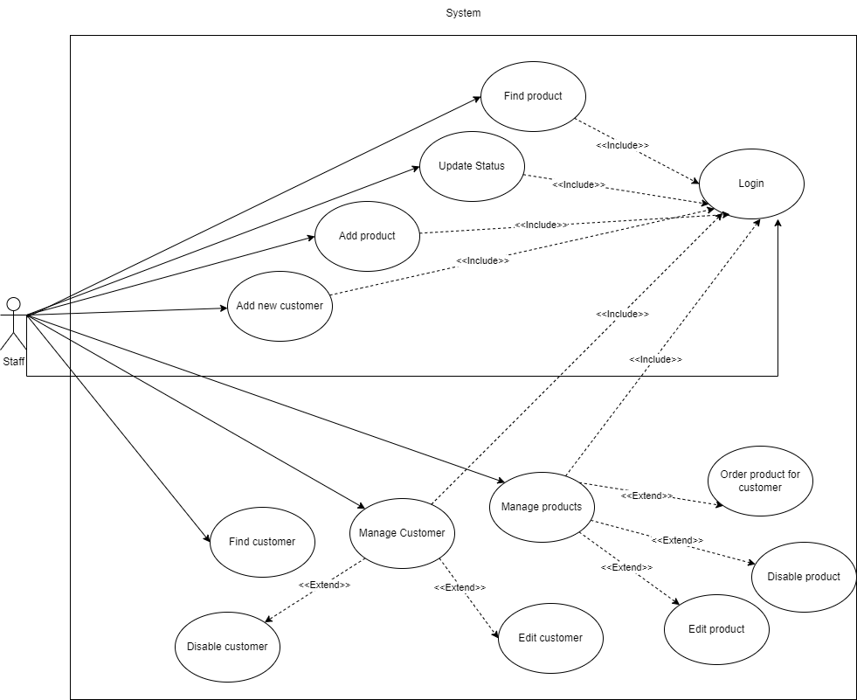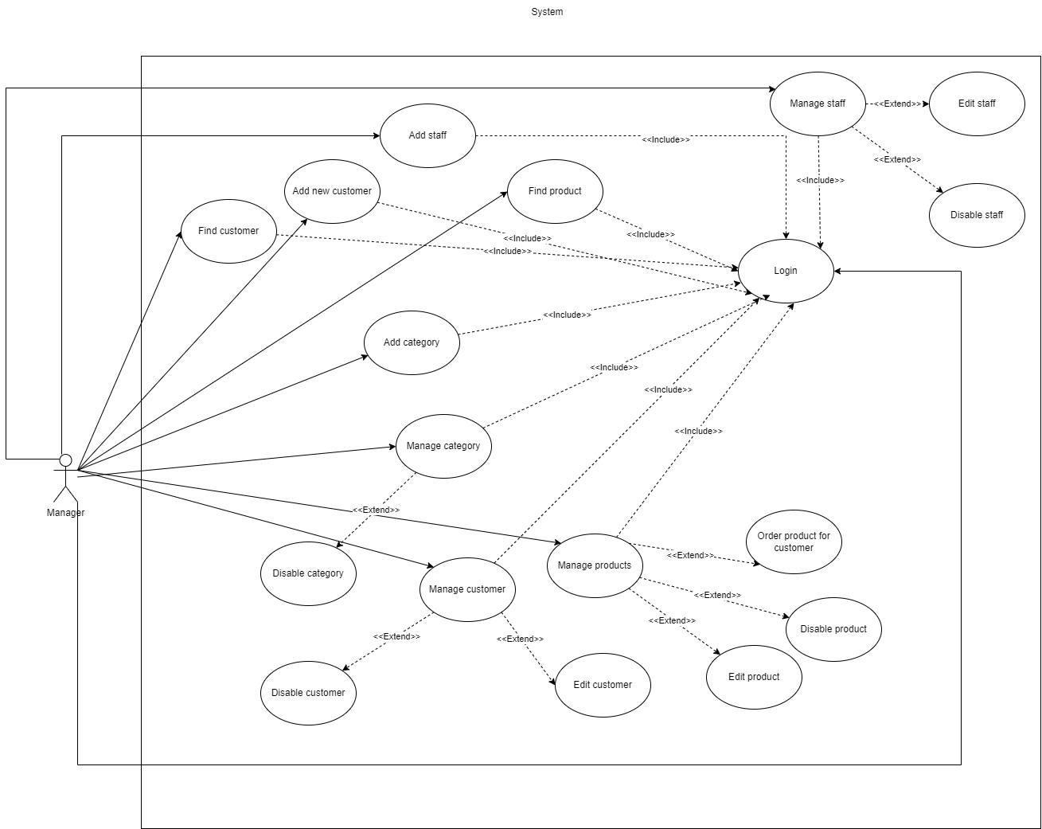
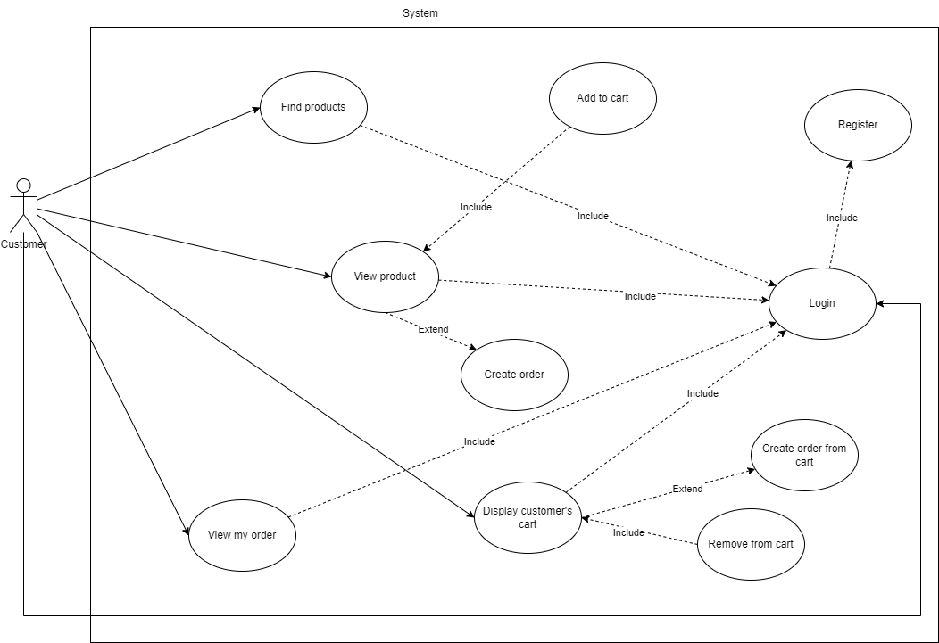

  - Login/Register
Use Case Name | Login
Use Case ID | UC_Login
Description | Users log in to the system to use functions
Actor | Customer, Staff, Manger
Organizational Benefits | This feature is used to define the roles and data users can access in the program.
Triggers | The user initiates the login process by entering their username and password and clicking the "Login" button
Preconditions | The user must be registered in the system.  The application is running and the login window is displayed.
Postconditions | Success:  - A success message is displayed according to the user’s role.  - The user is redirected to their respective menu based on their role (user, admin, superadmin).  Fail:  - An error message is displayed: "Invalid username or password!"  - The login window remains open for the user to retry.
Main Course | - Step 1: Initialize and Display Login Window:  - Step 2: Handle Login Button Click:  - Step 3: Redirect Based on Role
Alternate Courses | • Invalid Username or Password:  - Step 1: User enters incorrect username or password.  - Step 2: Clicks "Login" and receives an error message: "Invalid username or password!"  • User Clicks Register Button:  - Step 1: User clicks the "Register" button.  - Step 2: The login window is closed and the registration process is initiated.
Exceptions | Database Connection Error:  - Step 1: Unable to connect to the database during authentication.  - Step 2: Display an error message: "An error occurred during the login process. Please try again."  • SQL Command Execution Error:  - Step 1: An error occurs during the SQL query execution.  - Step 2: Display an error message: "An error occurred during the login process. Please try again."  • Unexpected Error:  - Step 1: An unexpected error occurs.  - Step 2: Display an error message: "An error occurred during the login process. Please try again."

Use Case Name | Register
Use Case ID | UC_Register
Description | Customer create their new user and information.
Actor | Customers
Organizational Benefits | Create new information
Triggers | Customer click register button
Preconditions | The application is running and the registration window is displayed.  The username must be unique and not already in use.
Postconditions | Success:  - A success message is displayed: "Registration successful!"  - The registration window is closed.  - The user is redirected to the login page.  Failure:  - An error message is displayed indicating the problem (e.g., duplicate username, invalid data).  - The registration window remains open for the user to correct the errors.
Main Course | - Step 1: nitialize and Display Registration Window:  - Step 2: Handle Register Button Click:
Alternate Courses | Duplicate Username:  - Step 1: User enters a username that already exists.  - Step 2: User clicks "Register" and receives an error message: "Username is duplicated. Please choose a different username."  Invalid Input Data:  - Step 1: User enters invalid data (e.g., incorrect date format, invalid email).  - Step 2: User clicks "Register" and receives an appropriate error message indicating the issue.
Exceptions | • Database Connection Error:  - Step 1: Unable to connect to the database during registration.  - Step 2: Display an error message: "An error occurred during registration. Please try again."  • SQL Command Execution Error:  - Step 1: An error occurs during SQL query execution (e.g., insert operations).  - Step 2: Rollback the transaction and display an error message: "An error occurred during registration. Please try again."  • Unexpected Error:  - Step 1: An unexpected error occurs.  - Step 2: Rollback the transaction and display an error message: "An error occurred during registration. Please try again."

  - Display Product
Use Case Name | Display Products
Use Case ID | UC_DisplayProduct
Description | Customers want to go through all of the available products.  Staffs want to view all of the products list.
Actor | Customer, staff, Manager
Organizational Benefits | View and know about products information  Make orders or add to the customer’s cart
Triggers | The function will be activated when the user choose the display product option in their menu.
Preconditions | - The application is running and the user has selected to view products.  - User authentication has determined their role.
Postconditions | Success:  - A list of products with action buttons is shown.  - The user can interact with the products based on their role.  Failure:  - An error message is shown and the user is returned to the previous menu..
Main Course | Step 1: Initialize and Display Product Window  Step 2: Retrieve and Display Product Data
Alternate Courses | AC 1: Role-Based Visibility:  - Step 1: User role is "user", "admin", or "superadmin".  - Step 2: Display buttons with different visibility based on the role:  - Users see "Add to Cart" and "Order" buttons.  - Admins and Superadmin see "Edit", "Disable", and "Order for Customer" buttons.  AC 2: No Products Available:  - Step 1: The query returns no results.  - Step 2: Display a message indicating no products are available.
Exceptions | EX 1: Database Connection Error:  - Step 1: Unable to connect to the database.  - Step 2: Display an error message: "An error occurred while retrieving product data. Please try again."  EX 2: SQL Command Execution Error:  - Step 1: An error occurs during SQL query execution.  - Step 2: Display an error message: "An error occurred while retrieving product data. Please try again."  EX 3: Unexpected Error:  - Step 1: An unexpected error occurs.  - Step 2: Display an error message: "An unexpected error occurred. Please try again."

  - Order for customer
Use Case Name | Order For Customer
Use Case ID | UC_OrderForCustomer
Description | Staff make order for customer
Actor | Staff
Organizational Benefits | Customers can order directly through staff members or managers
Triggers | Staffs can pick the “order for customer” option
Preconditions | - Customer must be registered in the system.  - Product must be available.
Postconditions | Successfully:  - Staff successfully put in a new order for the customer.  Fail:  - Staff failed to create a new order for the customer.
Main Course | - Step 1: Chose the Order button next to the desired product.  - Step 2: Enter the ID of the customer that’s making the order through Staff.  - Step 3: Fill the order information and submit.
Alternate Courses | Continue to make another order for the customer.  After submitting the order for the customer. Redo the steps to make another order.
Exceptions | Ex 1: The quantity of products in stock is insufficient  - Step 1: Display message: “The quantity of products in stock is insufficient for the order”.  - Step 2: Re-enter the sufficient amount to place the order or choose another product to order for the customer.  EX 2: Invalid data type filled in information  - Step 1: Display error message.  - Step 2: Re-fill the correct information.  EX 3: Database connection error  - Step 1: Crash.  - Step 2: Turn the program back on.

  - Display Cart to Order or Remove
Use Case Name | Display Cart to order, edit or remove items from the cart
Use Case ID | UC_DisplayCartToOrderOrRemove
Description | Customer can see their shopping cart to place the order, remove items from cart or delete the items from the shopping cart.
Actor | Customer
Organizational Benefits | Customers can place order/edit or delete the item from the cart
Triggers | Customer click the view cart button
Preconditions | Customer must be logged in and have items in their cart.
Postconditions | Success:  - Cart items are displayed, and actions can be performed on them.  Fail:  - Customer cannot make any order or edit/removing items from the cart.
Main Course | - Step 1: Customer opens the display cart window.  - Step 2: System retrieves cart items from the database.  - Step 3: System displays cart items in a scrollable window.  Case 1: Customer want to make an order  - Step 1: Choose products to add into the shopping cart.  - Step 2: Fill in order information from the cart.  EX 2: Invalid data type filled in information  - Step 1: Display error message.  - Step 2: Re-fill the correct information.  - Step 3: Confirm order.  Case 2: Customer want to remove items from the shopping cart  - Step 1: Click the remove button next to product’s information in the cart.  - Step 2: Remove successfully.
Alternate Courses | Case 1: Customer continue to make another order or remove more product from the cart.  Case 2: Customer navigates back to the main menu.
Exceptions | Ex 1: The quantity of products in stock is insufficient  - Step 1: Display message: “The quantity of products in stock is insufficient for the order”.  - Step 2: Re-enter the sufficient amount to place the order or choose another product to order for the customer.  EX 2: Invalid data type filled in information  - Step 1: Display error message.  - Step 2: Re-fill the correct information.  EX 3: Database connection error  - If the system fails to connect to the database, an error message will displayed.

  - Add new Customer
Use Case Name | Add new Customer
Use Case ID | UC_AddCustomer
Description | Staff create a new user account for the customer
Actor | Staff
Organizational Benefits | Allows any staff to register a new customer by entering user and customer details.
Triggers | Staff choose add customer option
Preconditions | Customer’s information doesn’t already exist in database
Postconditions | Success: Register successfully  Failure: Failed to register new customer
Main Course | - Step 1: Choose Add Customer option in Staff’s menu screen.  - Step 2: Fill in all the necessary information to register.  - Step 3: Click Register button.
Alternate Courses | Case 1: Staff clicks the "Close" button without registering:  - Staff decides not to register a new customer and clicks the "Close" button.  - System closes the registration window and returns to the admin menu.  Case 2: Staff returns to Admin Menu from Registration window:  - Staff navigates back to the admin menu from the registration window without registering a new customer.
Exceptions | EX 1: Username already taken  - Step 1: Display error message  - Step 2: Re-enter new username  EX 2: Invalid data type filled in information  - Step 1: Display error message  - Step 2: Re-fill the correct information  EX 3: Database connection error  - If the system fails to connect to the database, an error message is displayed, and the registration process cannot proceed.

  - Add new Staff
Use Case Name | Add new Staff
Use Case ID | UC_AddStaff
Description | Manager create a new Admin user for new Staff member
Actor | Manager
Organizational Benefits | Create new Admin user for staff member
Triggers | Manager choose create new Admin option
Preconditions | New user information isn’t already exist in database
Postconditions | Success: Register successfully  Failure: Failed to create new user
Main Course | - Step 1: Choose add staff option in Super Admin’s menu screen.  - Step 2: Fill in all the necessary information to create the new user.  - Step 3: Chose the Register option.
Alternate Courses | Case 1: Manager clicks "Close" button without registering:  - If the system fails to connect to the database, an error message is displayed, and the registration process cannot proceed.  Case 2: Manager returns to Super Admin Menu from Registration window:  - Manager navigates back to the super admin menu from the registration window without registering a new staff member.
Exceptions | EX 1: Username already exist  - Step 1: Display error message  - Step 2: Re-enter new username  EX 2: Invalid data type filled in information  - Step 1: Display error message  - Step 2: Re-fill the correct information  EX 3: Database connection error  - If the system fails to connect to the database, an error message is displayed, and the registration process cannot proceed.

  - Add new Product
Use Case Name | Add new Product
Use Case ID | UC_AddProduct
Description | Staff add new information about newly imported products
Actor | Staff
Organizational Benefits | Add new information about newly imported products
Triggers | Staff choose add product option
Preconditions | Staff login
Postconditions | Success:  - The new product is added to the database.  - The new product appears in the static list of products.  - A success message is displayed.  - The user is returned to the admin menu.  Fail:  - An error message is displayed if any required fields are empty, contain invalid data, or if there is an issue inserting the product into the database.  The product is not added to the database or the static list.
Main Course | - Step 1: Staff open Add Product window.  - Step 2: Staff fills required fields.  - Step 3: Staff click the save button.  - Step 4: Display success message.  - Step 5: Staff can either return to menu or add another product.
Alternate Courses | Alternate Course 1: Field(s) Left Blank  - Step 1: The user leaves one or more fields empty.  - Step 2: When clicking "Save":  - Display an error message: "All fields must be filled."  - The add product window remains open for user correction.  - Alternate Course 2: Invalid Stock Quantity  - Step 1: The user enters a non-numeric value in the Stock Quantity field.  - Step 2: When clicking "Save":  - Display an error message: "Stock Quantity must be a valid number."  - The add product window remains open for user correction.  Alternate Course 3: Invalid Category ID  - Step 1: The user enters a non-numeric value in the Category ID field.  - Step 2: When clicking "Save":  - Display an error message: "Category ID must be a valid number."  - The add product window remains open for user correction.  - Alternate Course 4: Invalid Price  - Step 1: The user enters a non-decimal value in the Price field.  - Step 2: When clicking "Save":  - Display an error message: "Price must be a valid decimal number."  - The add product window remains open for user correction.
Exceptions | EX 1: Database Connection Error:  - Step 1: Display error message: "An error occurred while adding the new product. Please try again."  - Step 2: Return to the input form without closing the window  EX 2: Database Insertion Error  - Step 1: Display error message: "An error occurred while adding the new product. Please try again."  - Step 2: Return to the input form without closing the window.

  - Add new Category
Use Case Name | Add new Category
Use Case ID | UC_AddCategory
Description | Manager will add a new product category
Actor | Manager
Organizational Benefits | Add a new product category
Triggers | Manager click add category in Super Admin Menu
Preconditions | Manager login on Super Admin account
Postconditions | Success: Create a new category successfully  Fail: Fail to create a new category
Main Course | - Step 1: Click Add category button in Super Admin’s menu screen  - Step 2: Fill all necessary information for the new category  - Step 3: Click Add button
Alternate Courses | Case 1: Manager click “Close” button without adding new category.  - Admin decides not to add a new category and clicks the "Close" button.  - System prompts confirmation before closing the window.  - If confirmed, system closes the category addition window and returns to the super admin menu.  Case 2: Admin returns to Super Admin Menu from Add Category window.  - Admin navigates back to the super admin menu from the category addition window without adding a new category.
Exceptions | EX 1: Invalid data type filled in information  - Step 1: Display error message  - Step 2: Re-fill the correct information  EX 2: Database connection error  - If the system fails to connect to the database, an error message is displayed, and the addition process cannot proceed.

  - Edit Product
Use Case Name | Edit Product
Use Case ID | UC_EditProduct
Description | Staffs can edit product information
Actor | Staff
Organizational Benefits | Edit product information
Triggers | Staff click edit product button
Preconditions | Product must exist in database
Postconditions | Success: Updated product information is saved to the system.  Fail: Can’t edit product.
Main Course | - Step 1: Click Display Product to open the list of products.  - Step 2: Click Edit product option.  - Step 3: Edit new product information and then choose save.  - Step 4: Edit successfully.
Alternate Courses | Case 1: Staff clicks "Close" button without saving changes:  - Staff decides not to save the changes and clicks the "Close" button.  - System prompts confirmation before closing the window.  - If confirmed, system closes the edit product information window and returns to the product display menu.  Case 2: Staff returns to Product Display Menu from Edit Product Information window:  - Staff go back to the product display menu from the edit product information window without saving changes.
Exceptions | EX 1: Can’t find product  - Step 1: Display error: “Can’t find product”.  - Step 2: Re-enter valid product id to find.  EX 2: Invalid data type filled in information  - Step 1: Display error message  - Step 2: Re-fill the correct information  EX 3: Database connection error  - If the system fails to connect to the database, an error message is displayed, and the update process cannot proceed.
  - Edit Customer
Use Case Name | Edit Customer
Use Case ID | UC_EditCustomer
Description | Staff help customer edit their user information
Actor | Staff
Organizational Benefits | Staff helps keeping customer information up-to-date and accurate.
Triggers | Staff click edit customer button
Preconditions | Customer account must already exist within the database
Postconditions | Success: Edit customer successfully  Fail: Can’t edit customer’s user information
Main Course | - Step 1: Click the Display Customer list option.  - Step 2: Click Edit customer option.  - Step 3: Edit new Customer’s user information and then choose save.  - Step 5: Edit successfully.
Alternate Courses | Case 1: Staff clicks "Close" button without saving changes:  - Staff decides not to save the changes and clicks the "Close" button.  - System prompts confirmation before closing the window.  - If confirmed, system closes the edit customer information window and returns to the customer display menu.  Case 2: Staff returns to Customer Display Menu from Edit Customer Information window:  - Staff navigates back to the customer display menu from the edit customer information window without saving changes.
Exceptions | EX 1: Can’t find customer  - Step 1: Display error: “Can’t find customer”.  - Step 2: Re-enter the valid customer id to find their user.  EX 2: Invalid data type filled in information  - Step 1: Display error message.  - Step 2: Re-fill the correct information.  EX 3: Database connection error  - If the system fails to connect to the database, an error message is displayed, and the update process cannot proceed.

  - Edit Staff
Use Case Name | Edit Staff
Use Case ID | UC_EditStaff
Description | Manager find staff and edit their user information
Actor | Manager
Organizational Benefits | Edit staff information
Triggers | Manager click edit staff button
Preconditions | Staff account must exist in database
Postconditions | Success: Edit Staff successfully  Failure: Can’t edit Staff
Main Course | Step 1: Click Display Staff list in Super Admin menu.  Step 2: Find the staff’s user you want to edit and click Edit.  Step 3: Edit new staff’s user information and then choose save.  Step 4: Edit successfully.
Alternate Courses | Case 1: Manager clicks "Close" button without saving changes:  - Superadmin decides not to save the changes and clicks the "Close" button.  - System prompts confirmation before closing the window.  - If confirmed, system closes the edit staff information window and returns to the staff display menu.  Case 2: Manager returns to Staff Display Menu from Edit Staff Information window:  - Superadmin navigates back to the staff display menu from the edit staff information window without saving changes.
Exceptions | EX 1: Can’t find Staff  - Step 1: Display error: “Can’t find Staff”  - Step 2: Re-enter Staff id to find  EX 2: Invalid data type filled in information  - Step 1: Display message error.  - Step 2: Re-fill the correct information.  EX 3: Database connection error  - If the system fails to connect to the database, an error message is displayed, and the update process cannot proceed.

  - Find Product
Use Case Name | Find Product
Use Case ID | UC_FindProduct
Description | Customer or Staff can find product information
Actor | Customer or Staff
Organizational Benefits | Customer or Staff can easily find the desired product
Triggers | Customer or Staff click find product button in their menu
Preconditions | Product must already exists within the database
Postconditions | Success: Displaying the product you want to find  Fail: List null
Main Course | - Step 1: Click find product button in menu.  - Step 2: Enter the name of the product you want to find.  - Step 3: The screen will display all the products that have similar names like the one you’ve entered.
Alternate Courses
Exceptions | EX 1: Database connection error  - If the system fails to connect to the database, an error message is displayed, and the search process cannot proceed

  - Find Customer
Use Case Name | Find Customer
Use Case ID | UC_FindCustomer
Description | Staff can find customer information
Actor | Staff
Organizational Benefits | Staff can easily find customer’s information
Triggers | Staff click find Customer button in staff menu
Preconditions | Customer must already have an account in the database
Postconditions | Success: Display the information of the Customer you want to find  Failure: List null
Main Course | - Step 1: Click find button in menu.  - Step 2: Enter the name of the customer you want to find.  - Step 3: The screen will display all the customers that have similar names like the one you’ve entered.
Alternate Courses | Case 1: Staff clicks "Back" button without saving changes:  - Staff decides not to search for a customer and clicks the "Back" button.  - System clears the product list and returns to the respective menu (admin menu or superadmin menu).  Case 2: Staff returns to respective menu:  - Staff navigates back to their respective menu without performing a search.
Exceptions | EX 1: Database connection error  - If the system fails to connect to the database, an error message is displayed, and the search process cannot proceed.  EX 2: No cutomers match the search criteria:  - If no customers match the search criteria, the system displays an error message indicating that no customer were found.

  - Find staff
Use Case Name | Find Staff
Use Case ID | UC_FindStaff
Description | Manager can find staff information
Actor | Manager
Organizational Benefits | Staff can easily find staff’s information
Triggers | Manger click find staff button in manager menu
Preconditions | Staff must already have an account in the database
Postconditions | Success: Display staffs that matched with the search criteria.  Failure: List null.
Main Course | - Step 1: Click find button in menu.  - Step 2: Enter the name of the staff you want to find.  - Step 3: The screen will display all the staffs that have similar names like the one you’ve entered.
Alternate Courses | Case 1: Manager Clicks "Close" Button Without Searching:  - Manager decides not to search for a staff member and clicks the "Close" button.  - System clears the staff list and returns to the super admin menu.  Case 2: Manager Returns to Super Admin Menu:  - Manager navigates back to the super admin menu without performing a search.
Exceptions | EX 1: Database connection error  - If the system fails to connect to the database, an error message is displayed, and the search process cannot proceed.  EX 2: No Staff matches the search criteria:  - If no staff matches the search criteria, the system displays an error message indicating that no staff members were found.

  - Display customer
Use Case Name | DisplayCustomer
Use Case ID | UC_DisplayCustomer
Description | Staff can view all customer’s information
Actor | Staff
Organizational Benefits | Can view all of customer’s information
Triggers | Staff clicks display customer in staff menu
Preconditions | Customer must already have an account in the database
Postconditions | Success: Display a list of all the current customer’s information  Failure: List empty
Main Course | - Step 1: Staff clicks display customers in staff menu.  - Step 2: Menu display all of the customer’s information.
Alternate Courses | Case 1: Staff clicks "Back" button without any action:  - Staff decides not to perform any actions and clicks the "Back" button.  - System clears the customer list and returns to the main menu.
Exceptions | EX 1: Database connection error  - If the system fails to connect to the database, an error message is displayed, and the customer list cannot be retrieved.  EX 2: Error occurs during data retrieval:  - If an error occurs during data retrieval, the system displays a generic error message.

  - Display staff
Use Case Name | DisplayStaff
Use Case ID | UC_DisplayStaff
Description | Manager can view all staff’s information
Actor | Manager
Organizational Benefits | Can view all staff’s information
Triggers | Staff clicks display staffs in Super Admin menu
Preconditions | Staff must already have an account in the database
Postconditions | Success: Display a list of all the current staff’s information  Failure: List empty
Main Course | Step 1: Manager clicks display staffs in Super Admin menu  Step 2: Menu display all of the staff’s information
Alternate Courses | Manager clicks "Back" button without any action:  - Manager decides not to perform any actions and clicks the "Back" button.  - System clears the staff list and returns to the main menu.
Exceptions | EX 1: Database connection error  - If the system fails to connect to the database, an error message is displayed, and the staff list cannot be retrieved.  EX 2: Error occurs during data retrieval:  - If an error occurs during data retrieval, the system displays a generic error message.

  - Delete product
Use Case Name | DeleteProduct
Use Case ID | UC_DeleteProduct
Description | Staff can remove product from the database
Actor | Staff
Organizational Benefits | Remove product from the database
Triggers | Staff clicks delete product in staff menu
Preconditions | Product must already exist in the database
Postconditions | Success: Remove product successfully  Fail: Can’t remove product
Main Course | Step 1: Staff click delete product in staff menu.  Step 2: Enter ID of the product you wish to remove.  Step 3: Remove successfully.
Alternate Courses | Staff cancels the deletion:  - Staff decides not to proceed with the deletion and cancels the operation.  - System does not perform any update operation on the database.
Exceptions | EX 1: Can’t find product  - Step 1: Display error message  - Step 2: Re-enter valid product ID  EX 2: Invalid data type filled in information  - Step 1: Display error message  - Step 2: Re-fill the correct information  EX 3: Database connection error  - If the system fails to establish a connection to the database, an error message is displayed indicating the failure.

  - Delete customer
Use Case Name | DeleteCustomer
Use Case ID | UC_DeleteCustomer
Description | Marks a customer and their corresponding user account as inactive in the database
Actor | Staff
Organizational Benefits | Ensures customer records are up-to-date.
Triggers | Staff clicks delete customer in staff menu
Preconditions | Customer must already have an account in the database
Postconditions | Success: Remove customer successfully  Fail: Can’t remove customer
Main Course | - Step 1: Staff click delete customer in the Admin menu.  - Step 2: Enter ID of the customer you want to remove.  - Step 3: Remove successfully.
Alternate Courses | Staff cancels the deletion:  - Staff decides not to proceed with the deletion and cancels the operation.  - System does not perform any update operation on the database.
Exceptions | EX 1: Can’t find customer  - Step 1: Display error message  - Step 2: Re-enter valid customer ID  EX 2: Invalid data type filled in information  - Step 1: Display error message  - Step 2: Re-fill the correct information  EX 3: Database connection error  - If the system fails to establish a connection to the database, an error message is displayed indicating the failure.

  - Delete staff
Use Case Name | DeleteStaff
Use Case ID | UC_DeleteStaff
Description | Marks a staff member and their corresponding user account as inactive in the database using a transaction.
Actor | Manager
Organizational Benefits | Ensures staff records are up-to-date.
Triggers | Manager clicks delete staff in super admin menu
Preconditions | Staff must already have an account in the database
Postconditions | Success: Remove staff successfully  Fail: Can’t remove staff
Main Course | - Step 1: Manager click delete staff in Super Admin menu.  - Step 2: Select the staff that need to be remove.  - Step 3: Remove successfully.
Alternate Courses | Manager cancels the deletion:  - Manager decides not to proceed with the deletion and cancels the operation.  - System does not perform any update operation on the database.
Exceptions | EX 1: Can’t find staff  - Step 1: Display error message.  - Step 2: Re-enter staff ID.  EX 2: Invalid data type filled in information  - Step 1: Display error message.  - Step 2: Re-fill the correct information.  EX 3: Database connection error  - If the system fails to establish a connection to the database, an error message is displayed indicating the failure..

  - Delete category
Use Case Name | DeleteCategory
Use Case ID | UC_DeleteCategory
Description | Marks a category and its associated products as inactive in the database.
Actor | Staff
Organizational Benefits | Ensures product and category records are up-to-date.
Triggers | Staff clicks delete category in Admin menu
Preconditions | Category must already exist in the database
Postconditions | Success: Remove category successfully  Fail: Can’t remove category
Main Course | - Step 1: Staff click delete category in Admin menu.  - Step 2: Enter ID of the category that needs to be remove.  - Step 3: Remove successfully.
Alternate Courses | Staff cancels the deletion:  - Staff decides not to proceed with the deletion and cancels the operation.  - System does not perform any update operation on the database.
Exceptions | EX 1: Can’t find category  - Step 1: Display error message.  - Step 2: Re-enter category ID.  EX 2: Invalid data type filled in information  - Step 1: Display error message.  - Step 2: Re-fill the correct information.  EX 3: Database connection error  - If the system fails to establish a connection to the database, an error message is displayed indicating the failure.

- Activity Diagram: 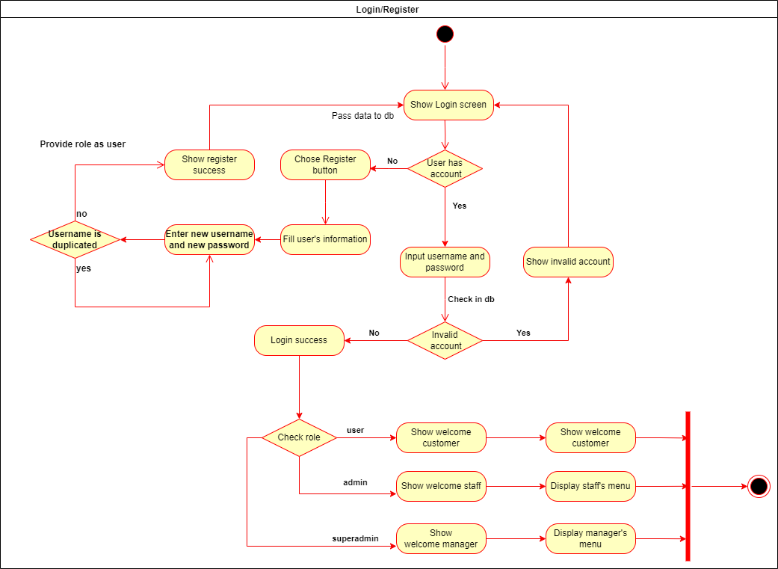
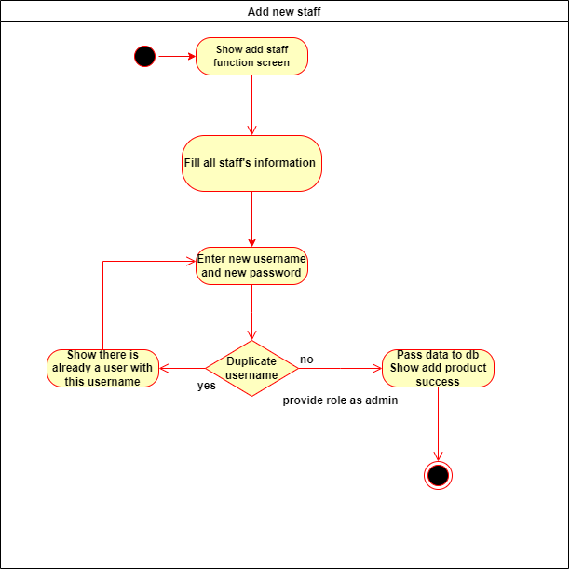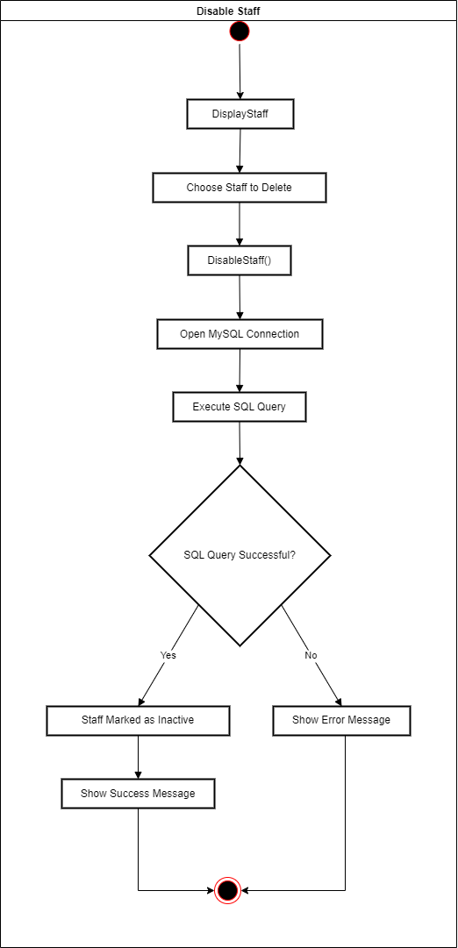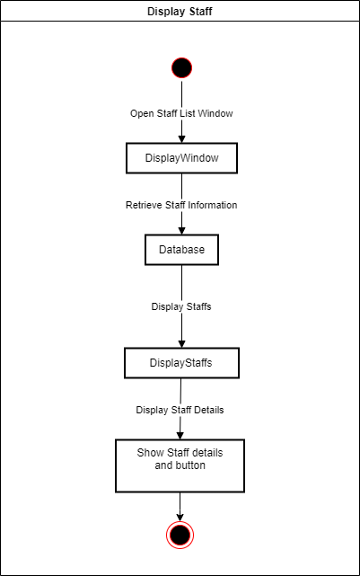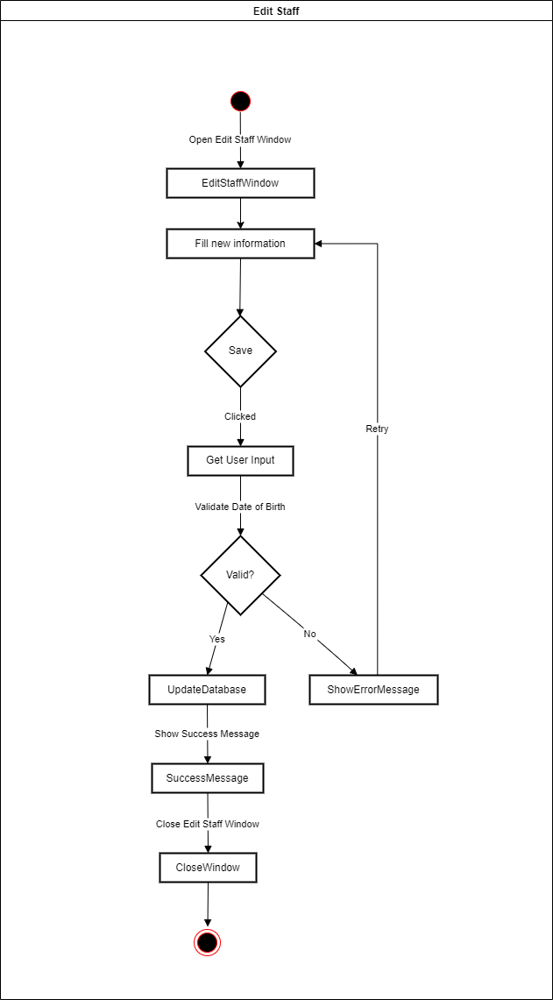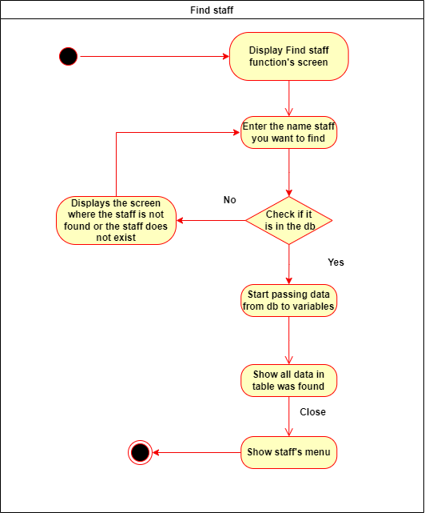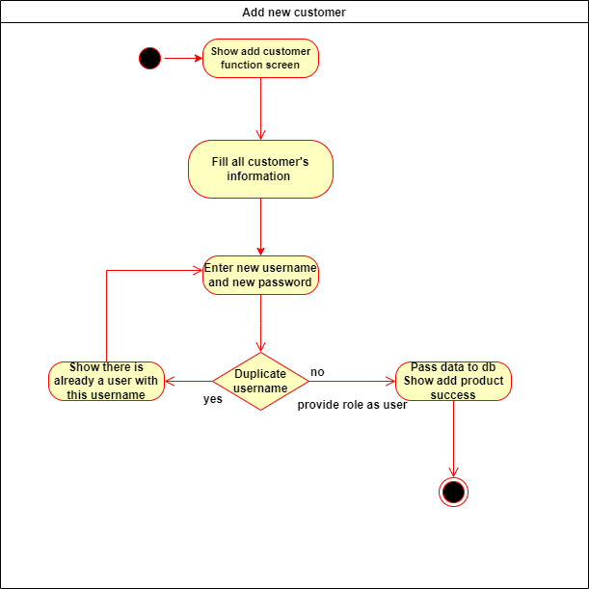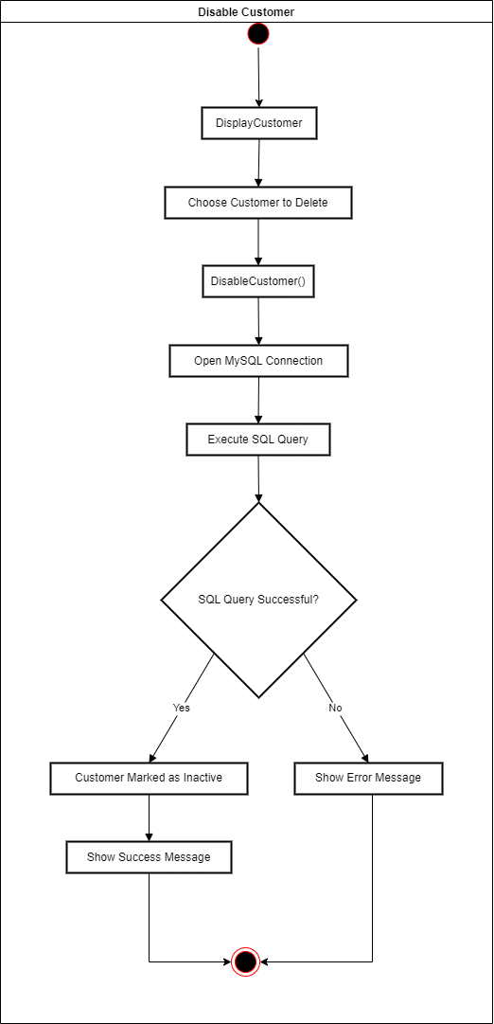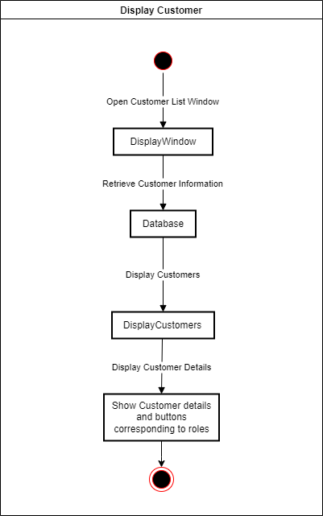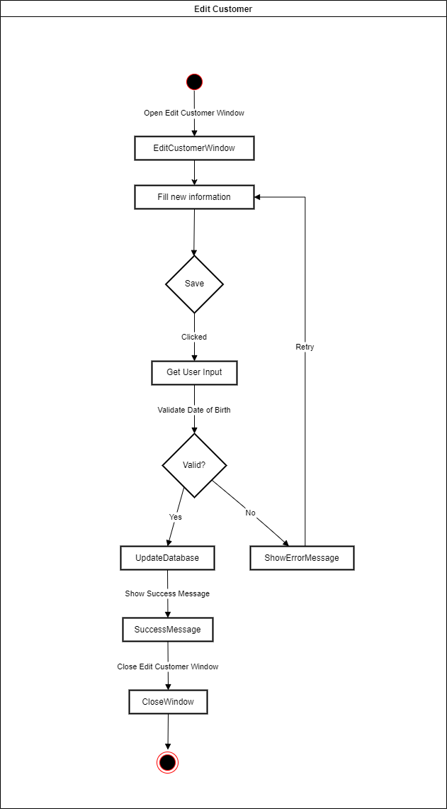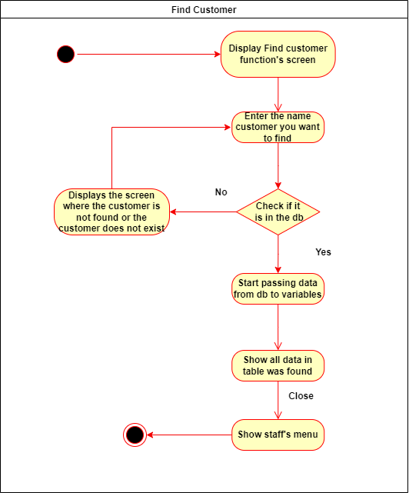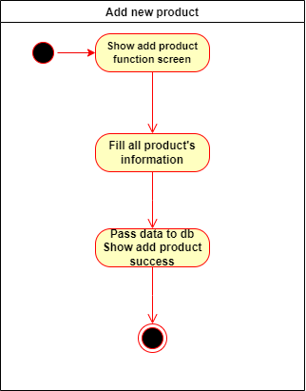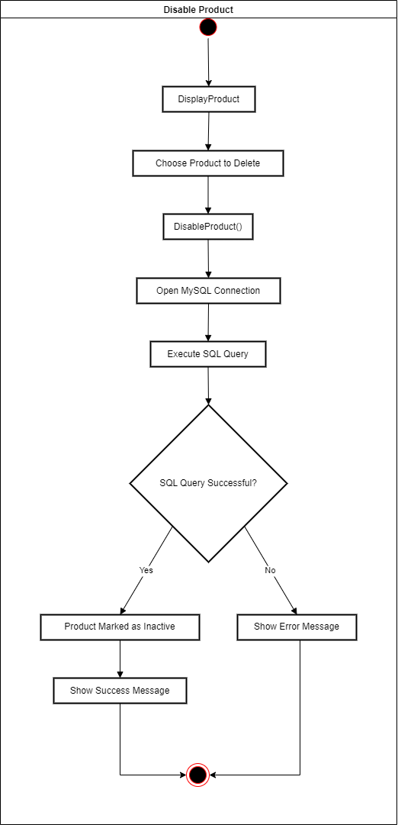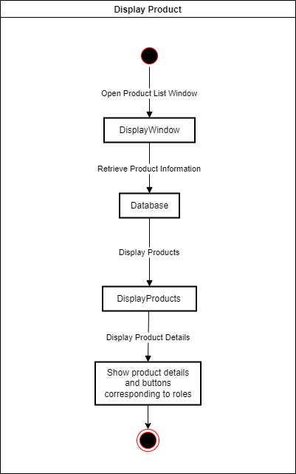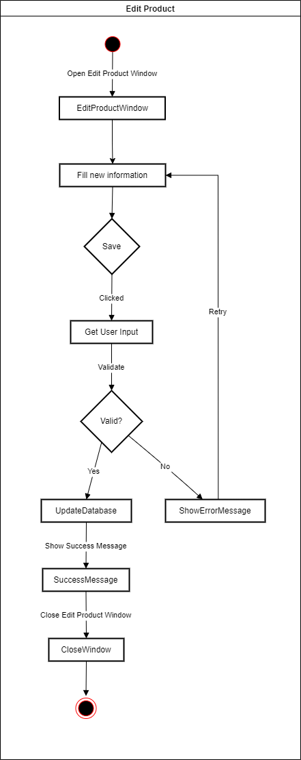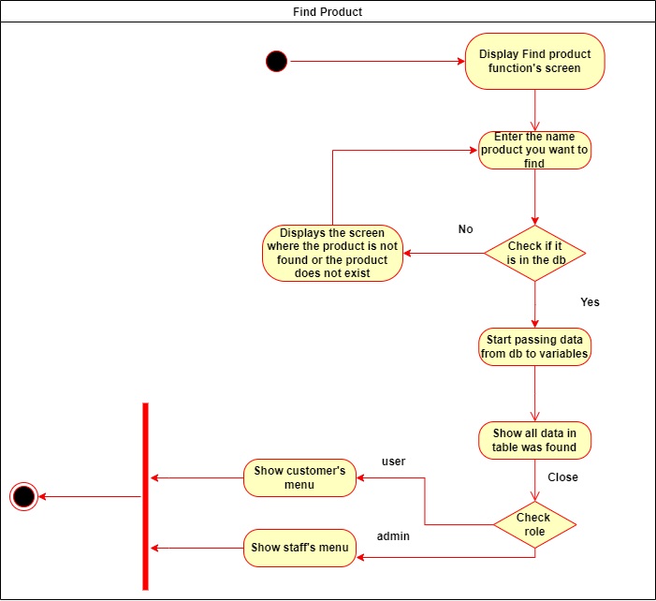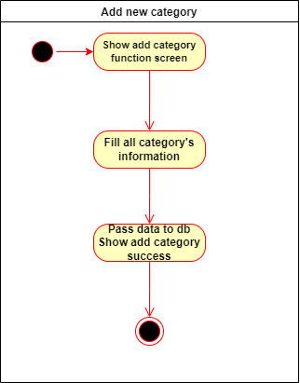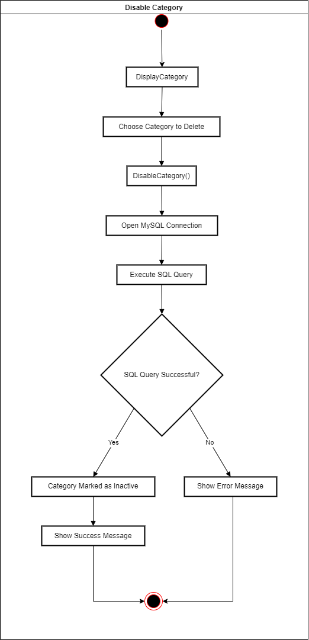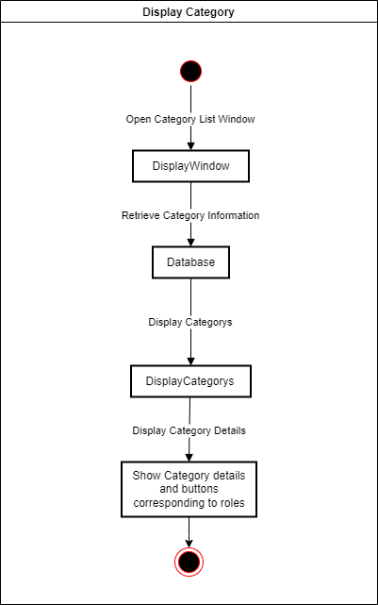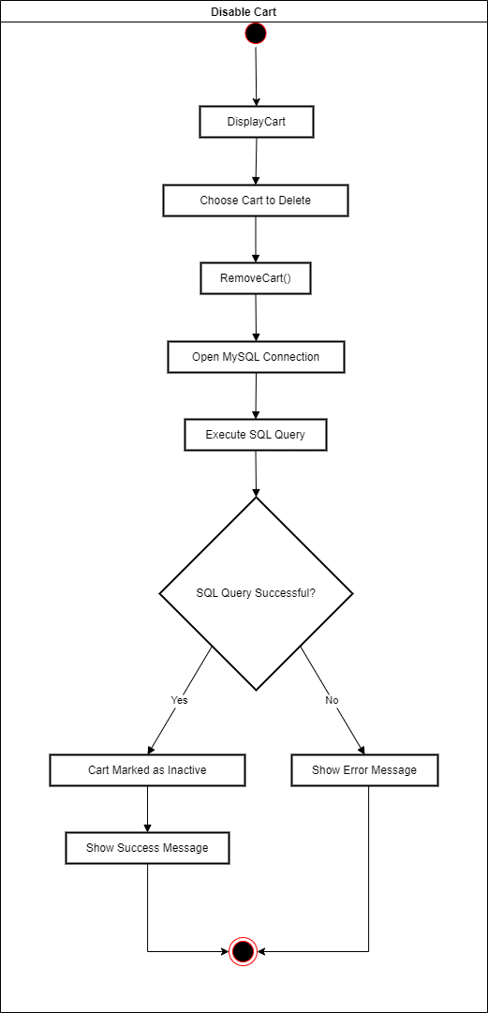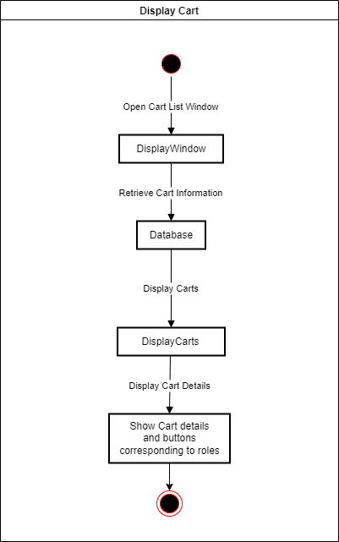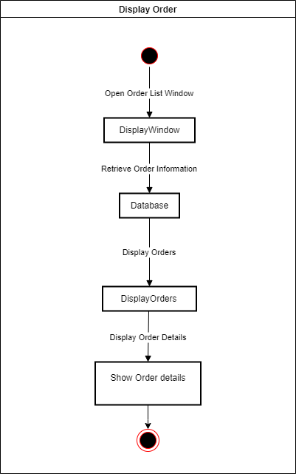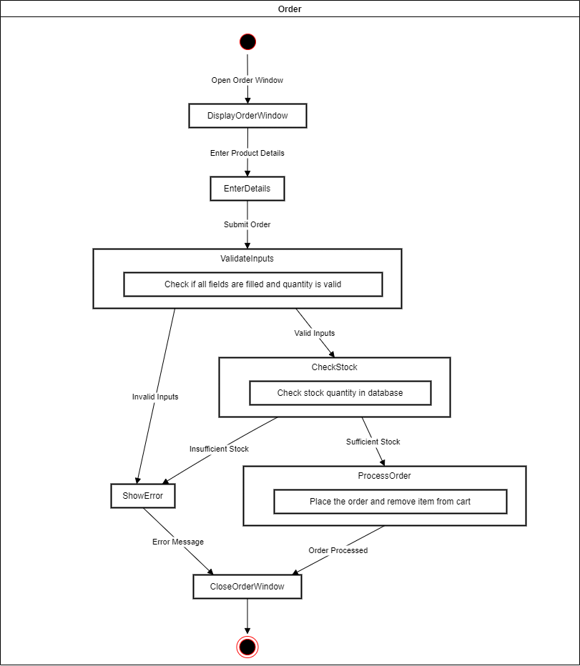

Design Details
- UI Design
< Design the main user interface and for each features of the software >
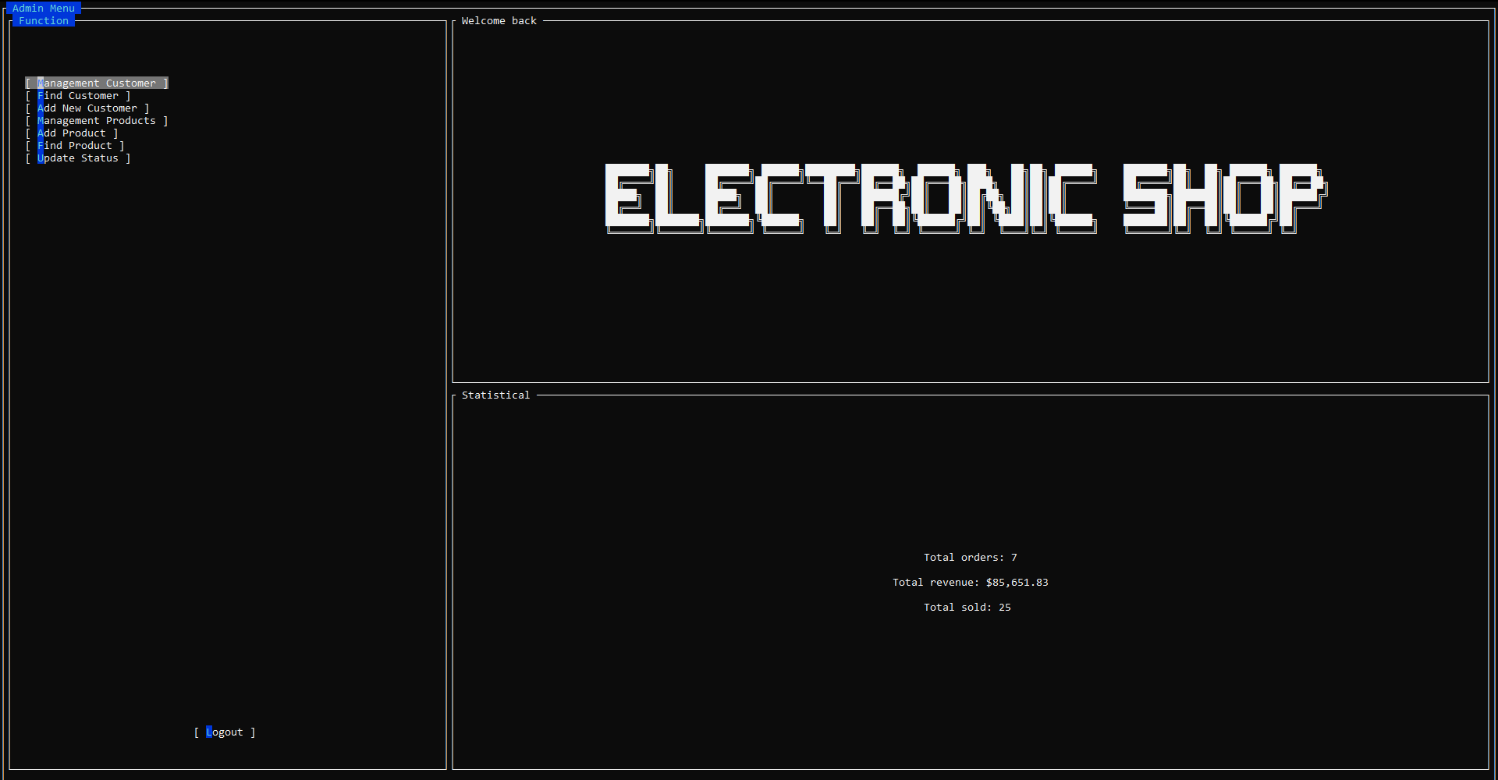

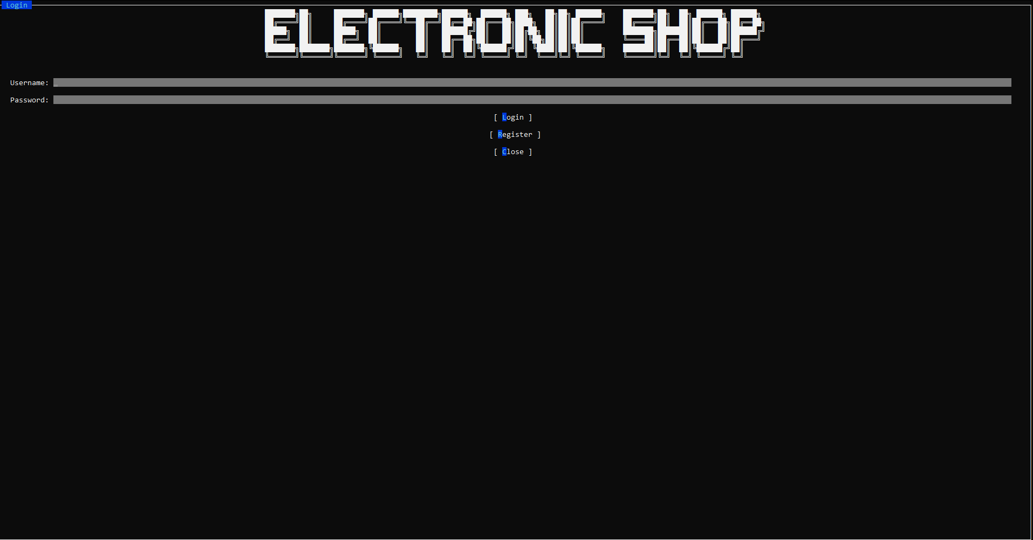
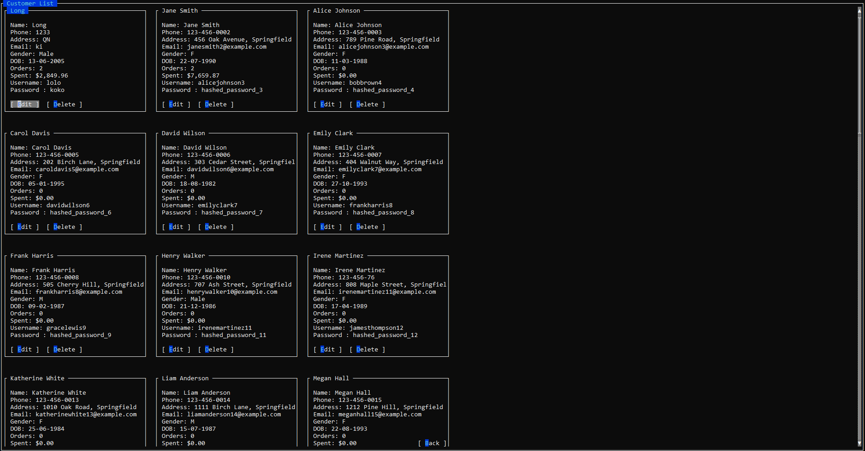

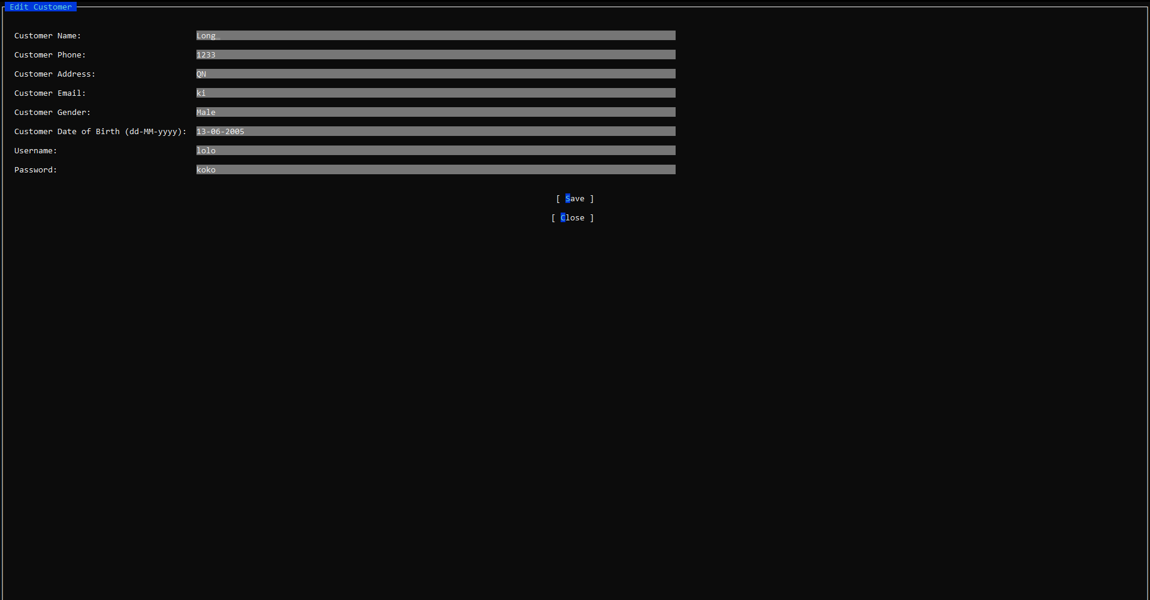

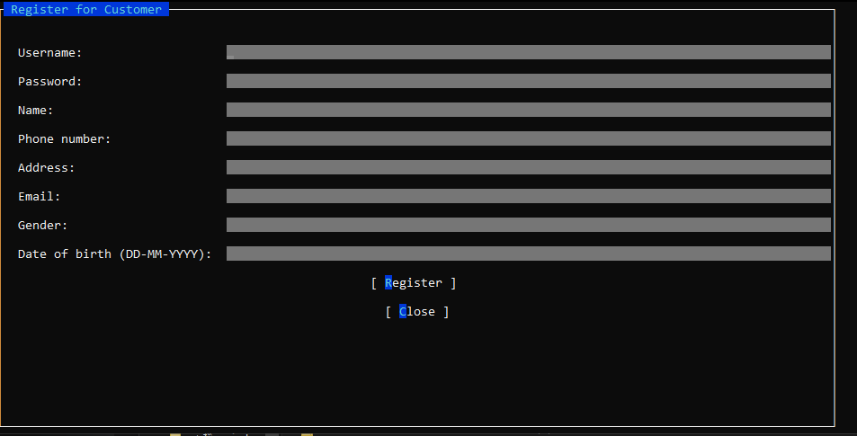

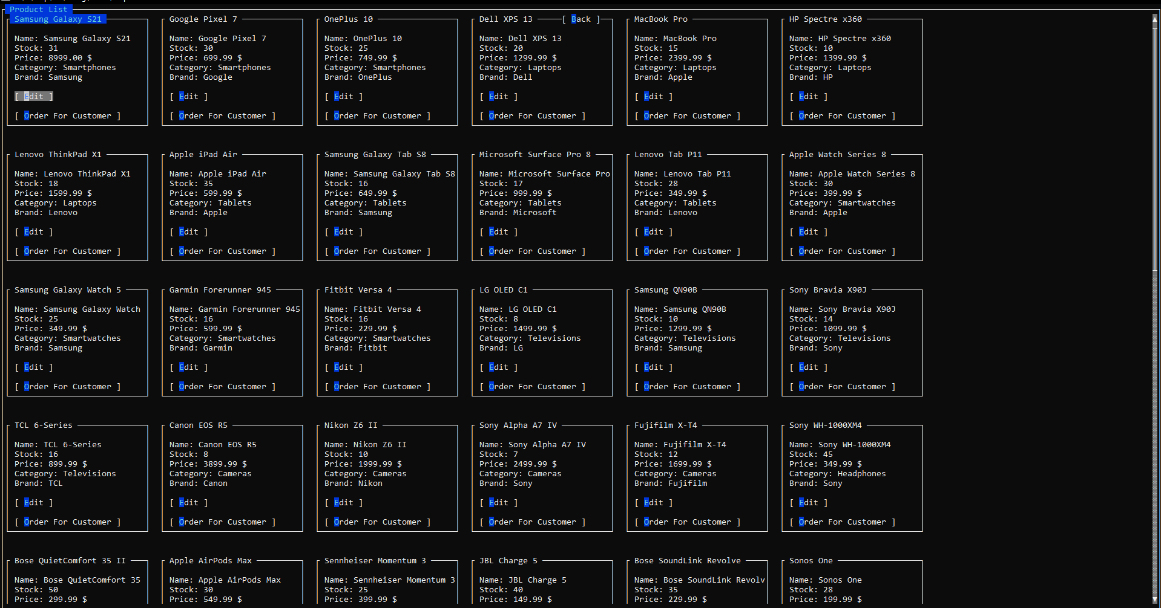
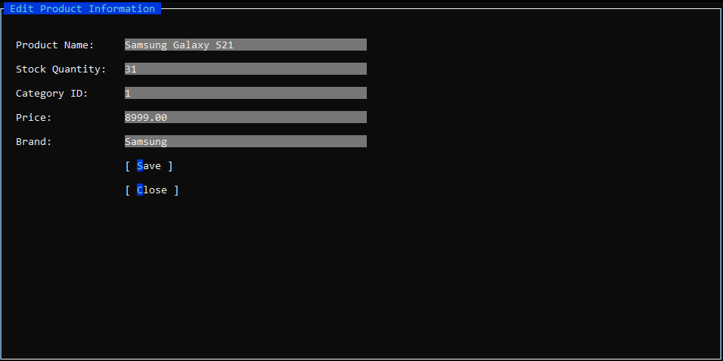

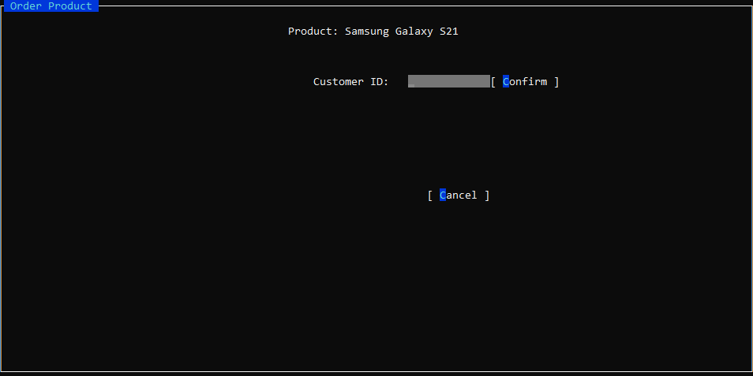

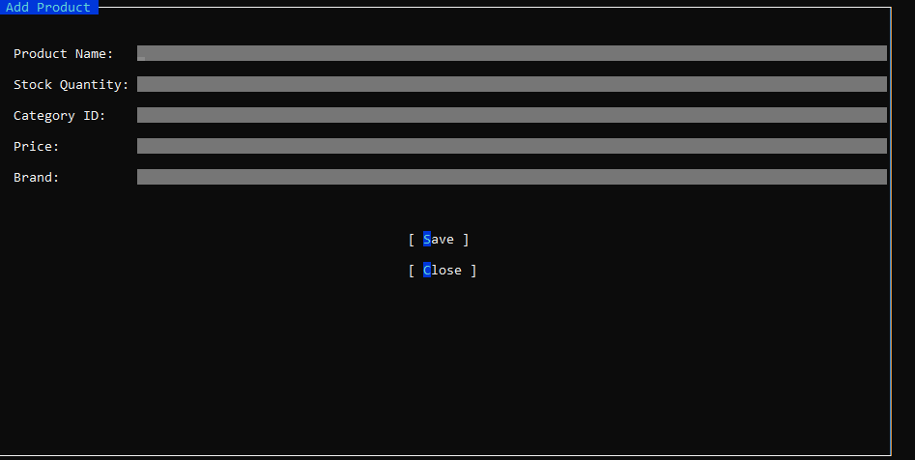

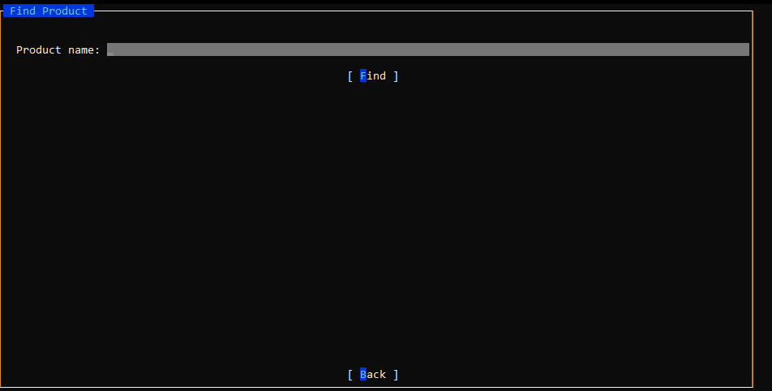
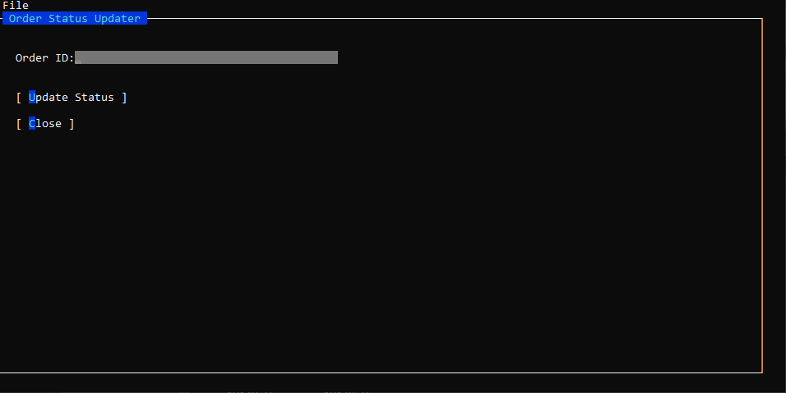

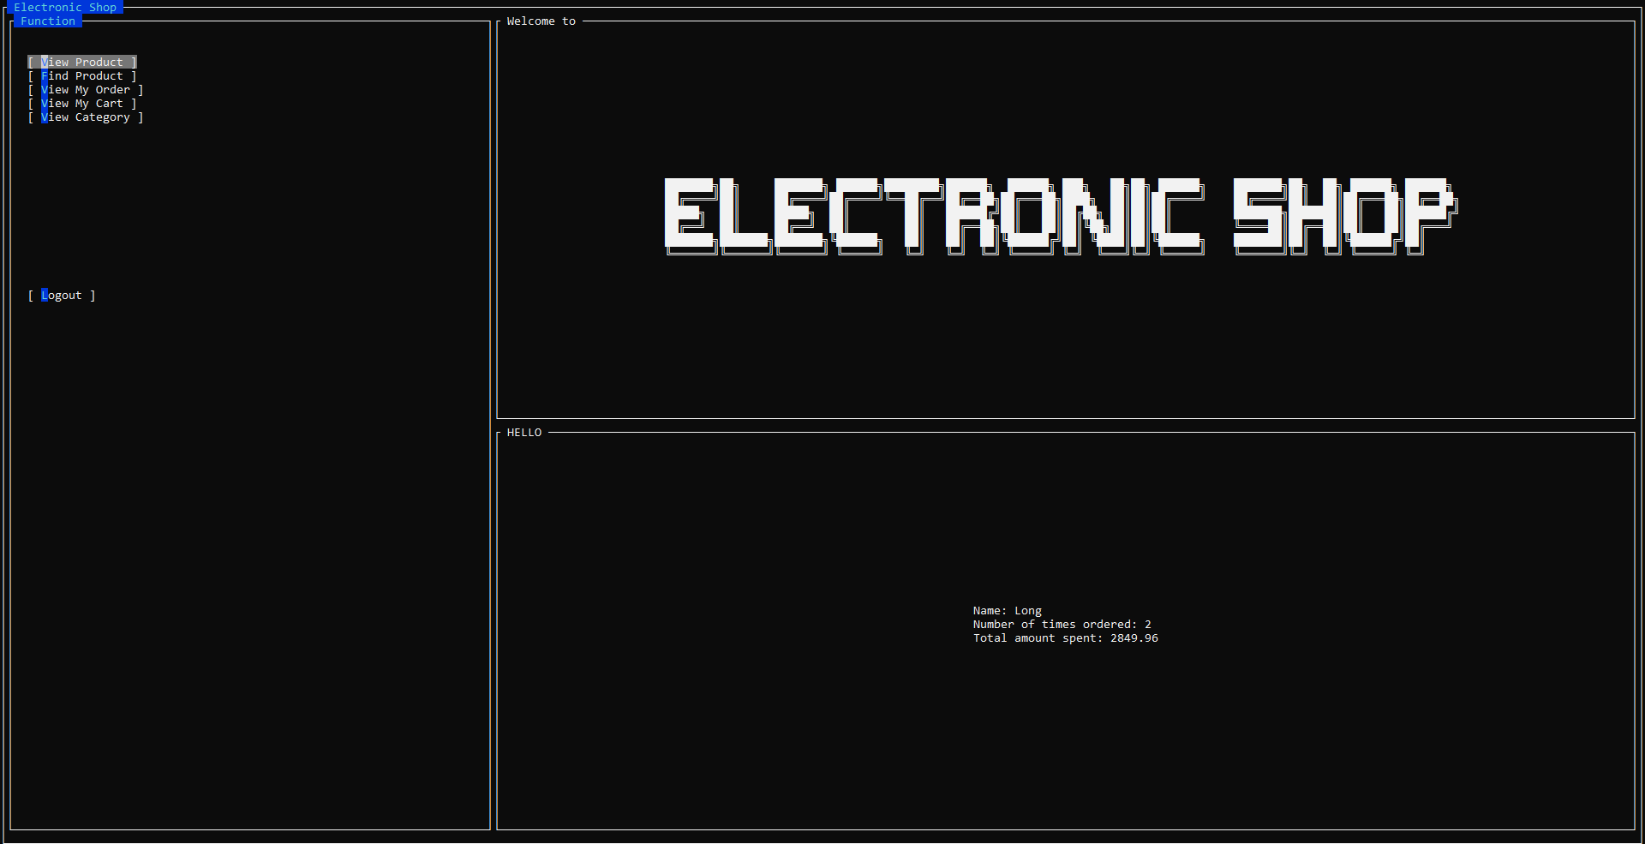
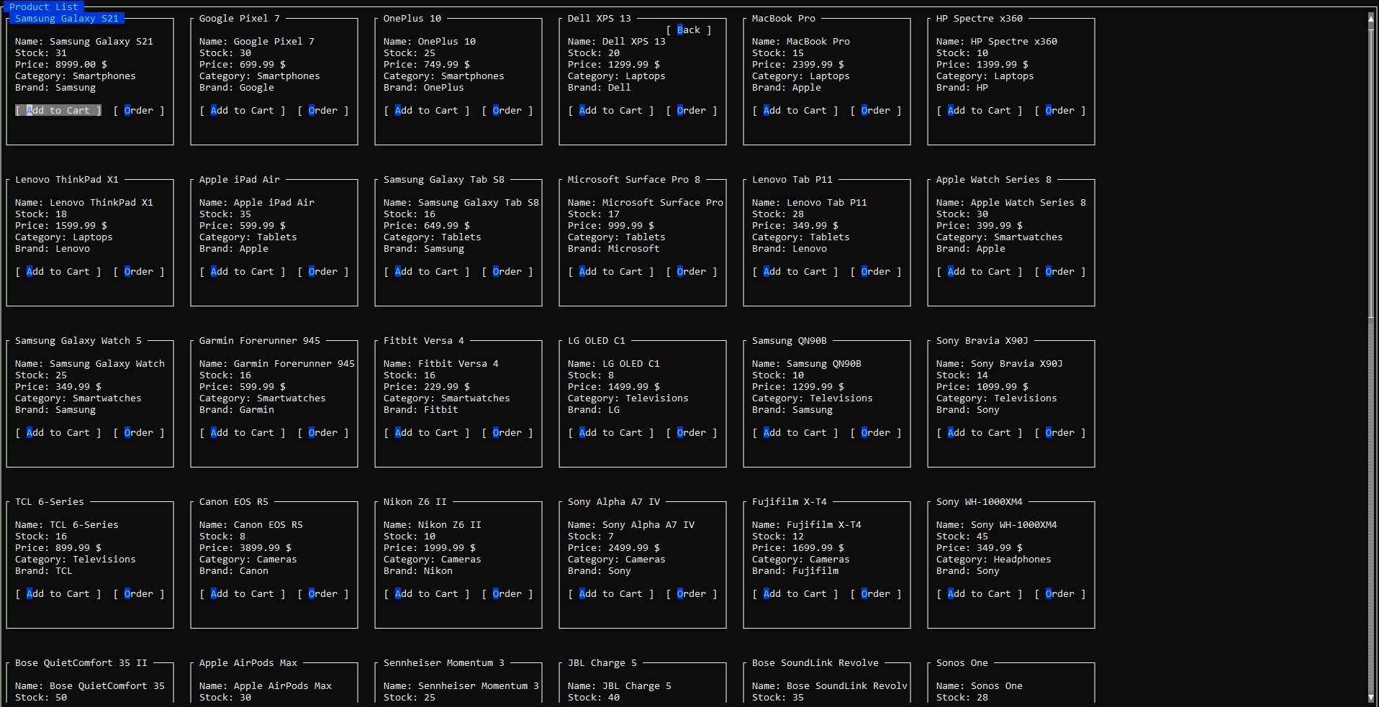

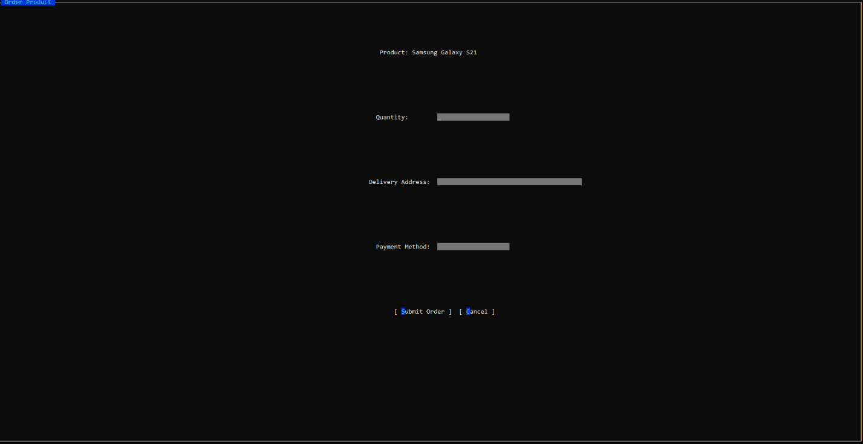
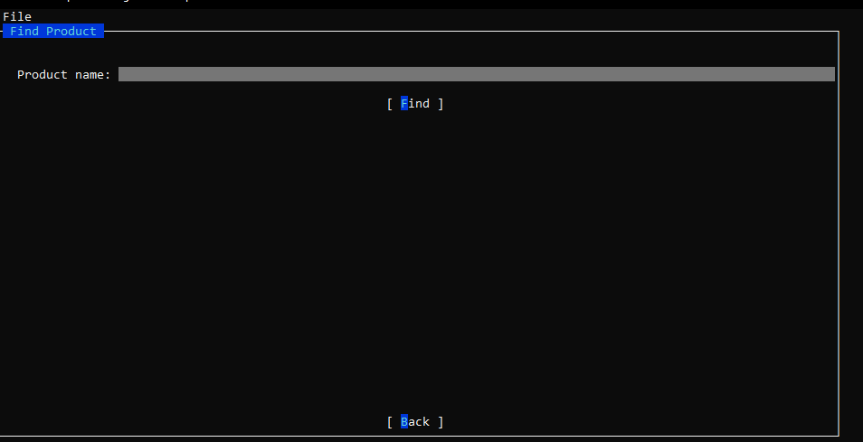

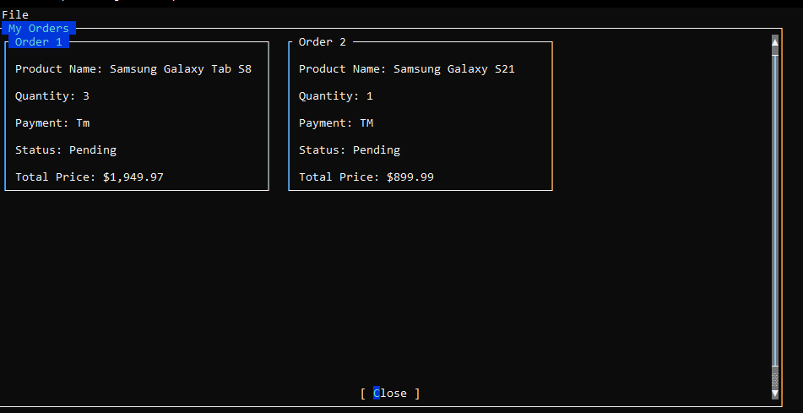
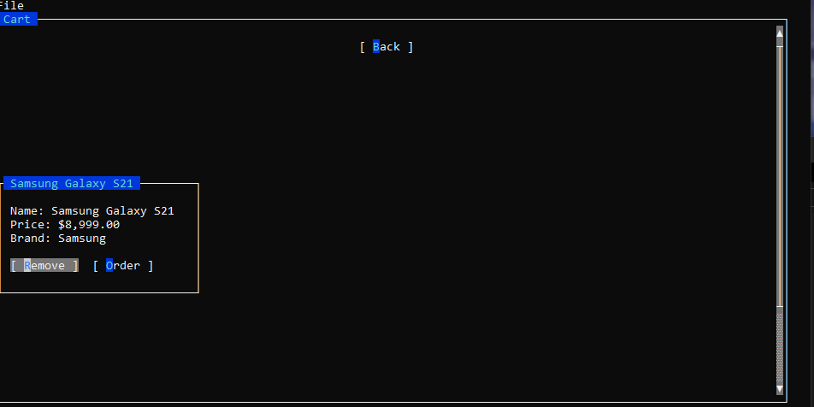

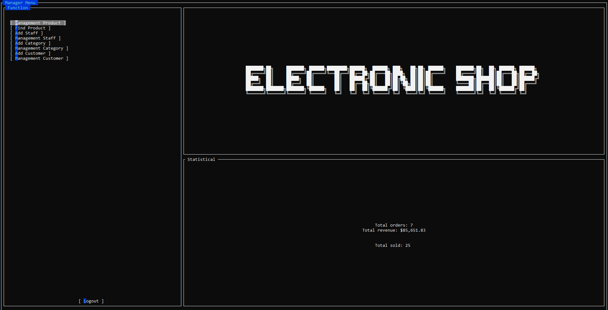
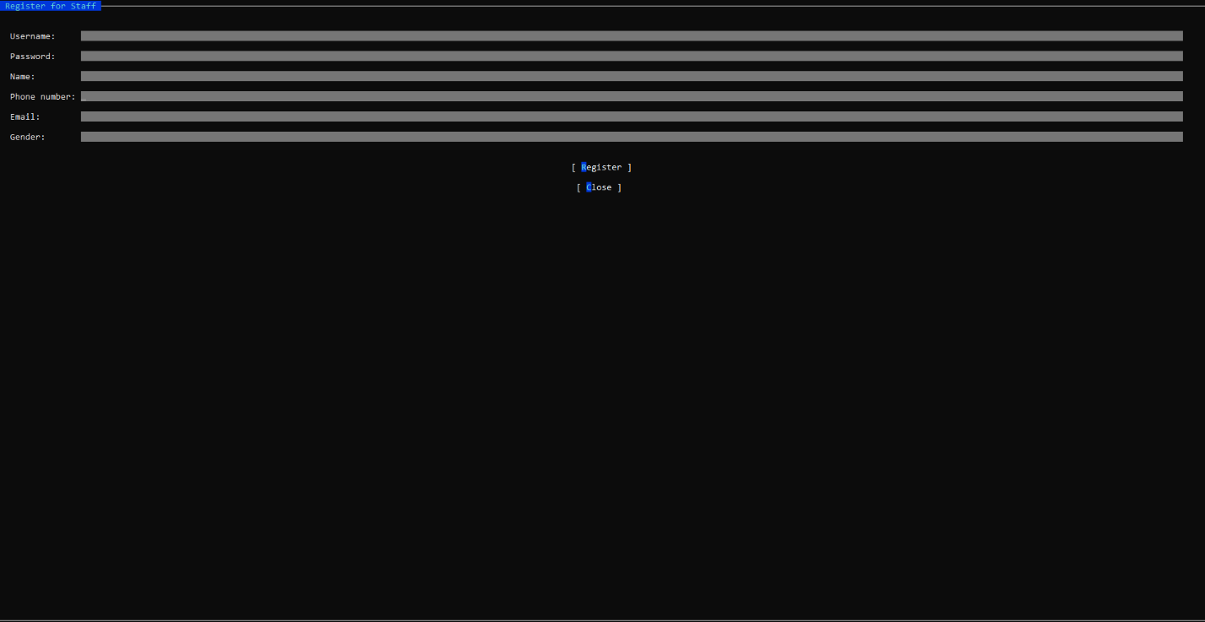

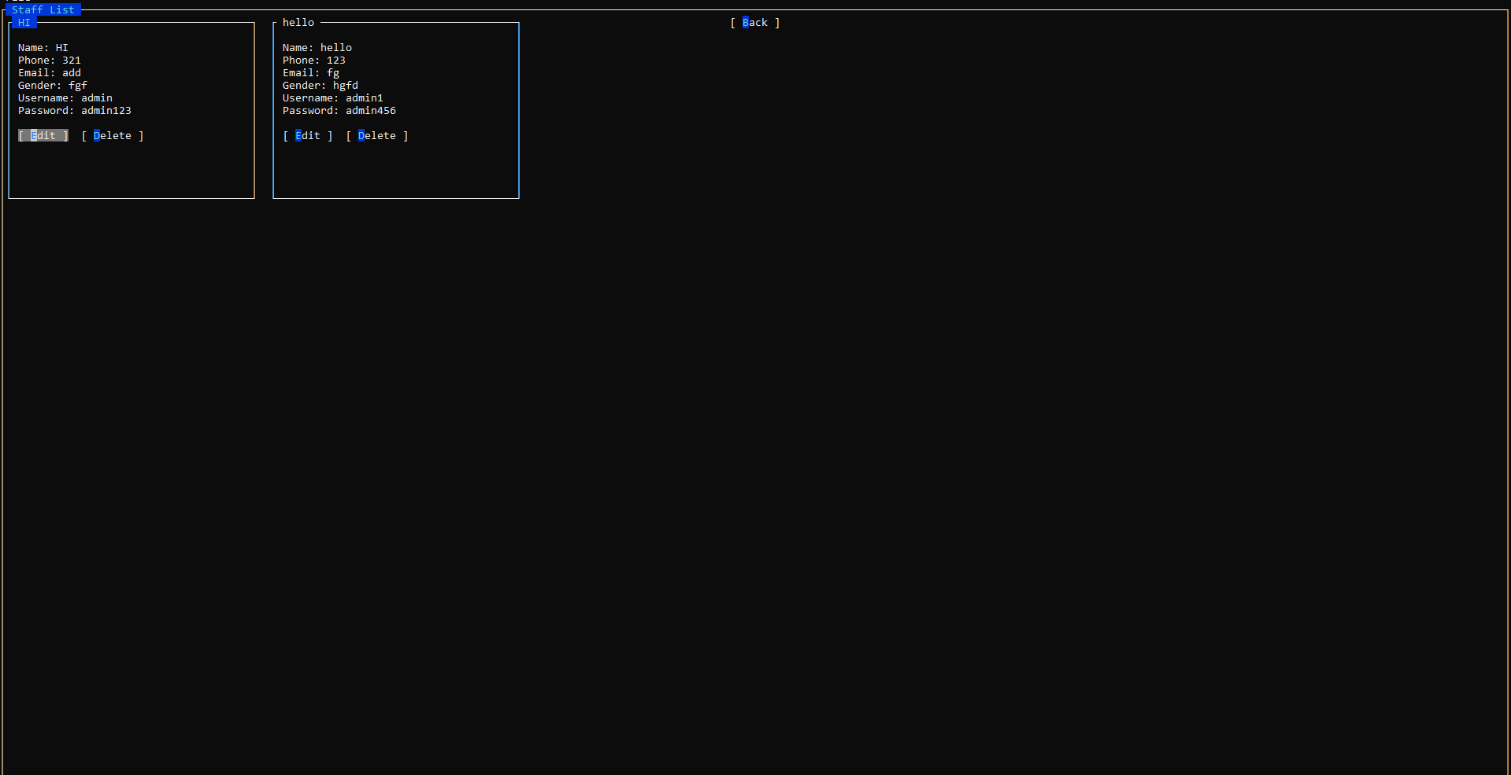
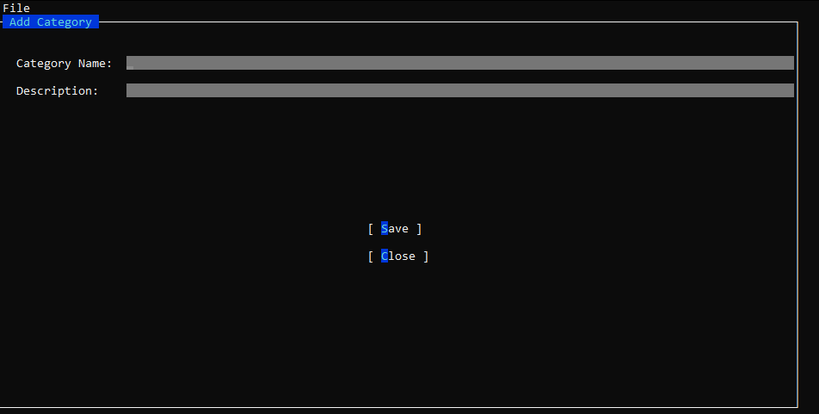

- Code Design (Class Diagram)
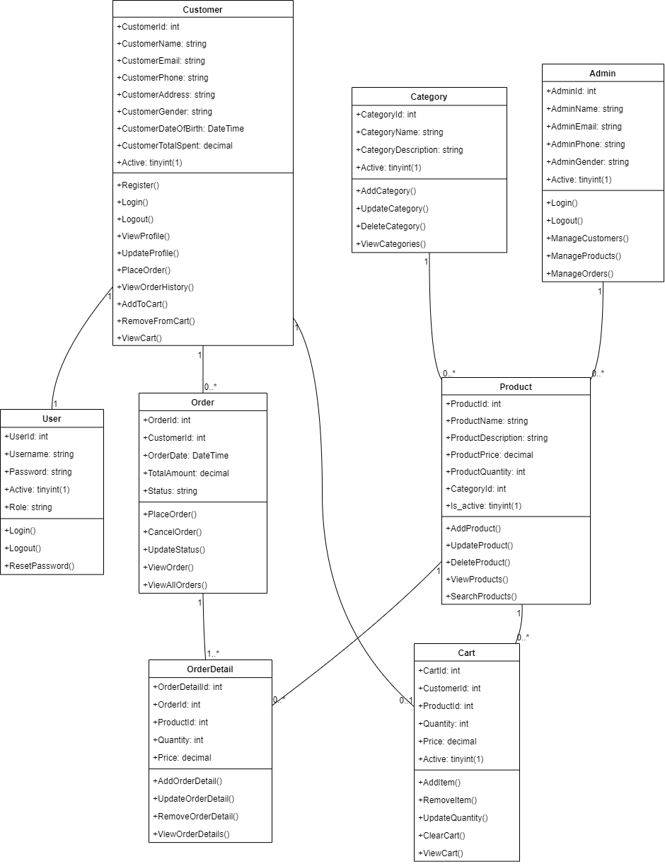

- Sequence Diagram
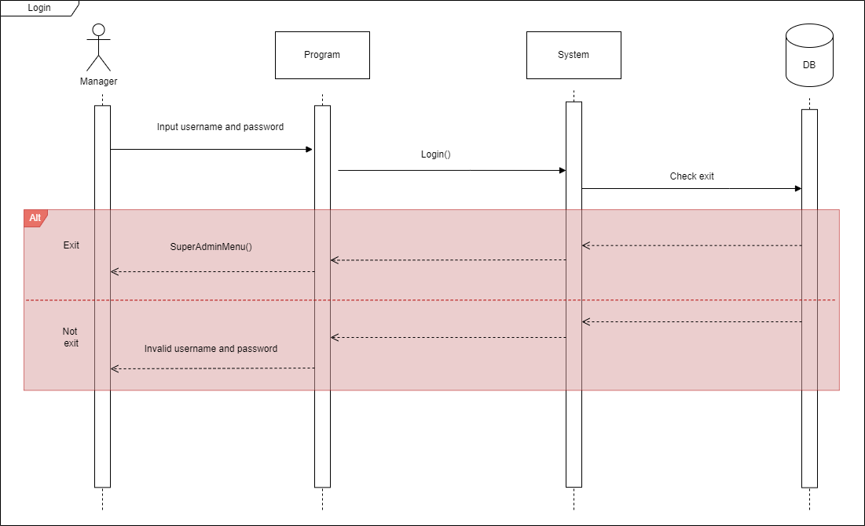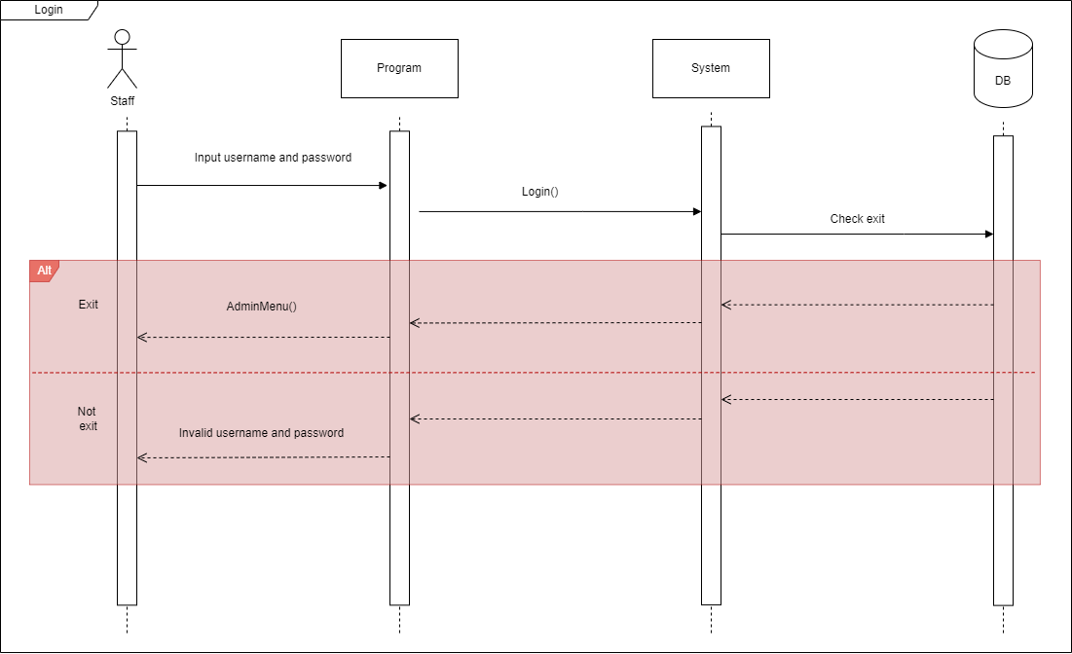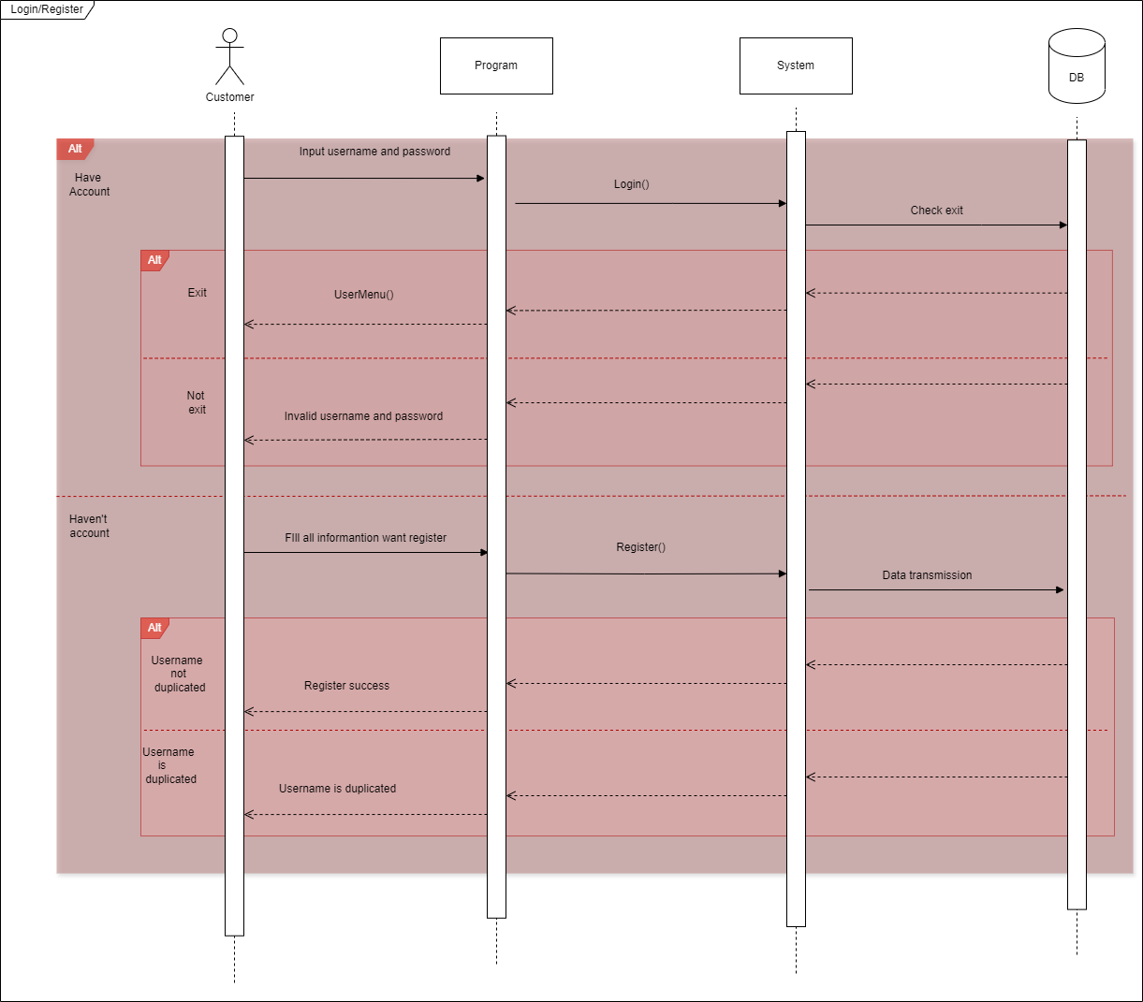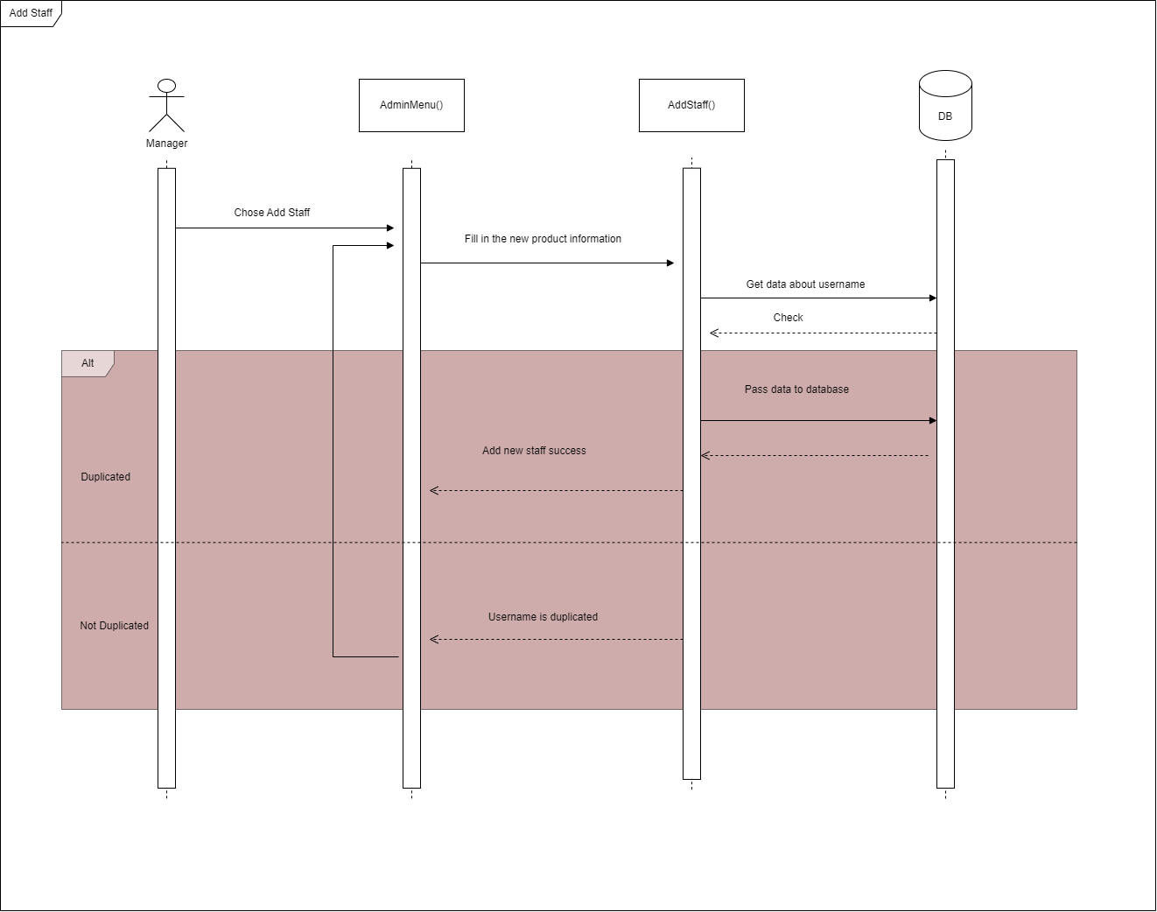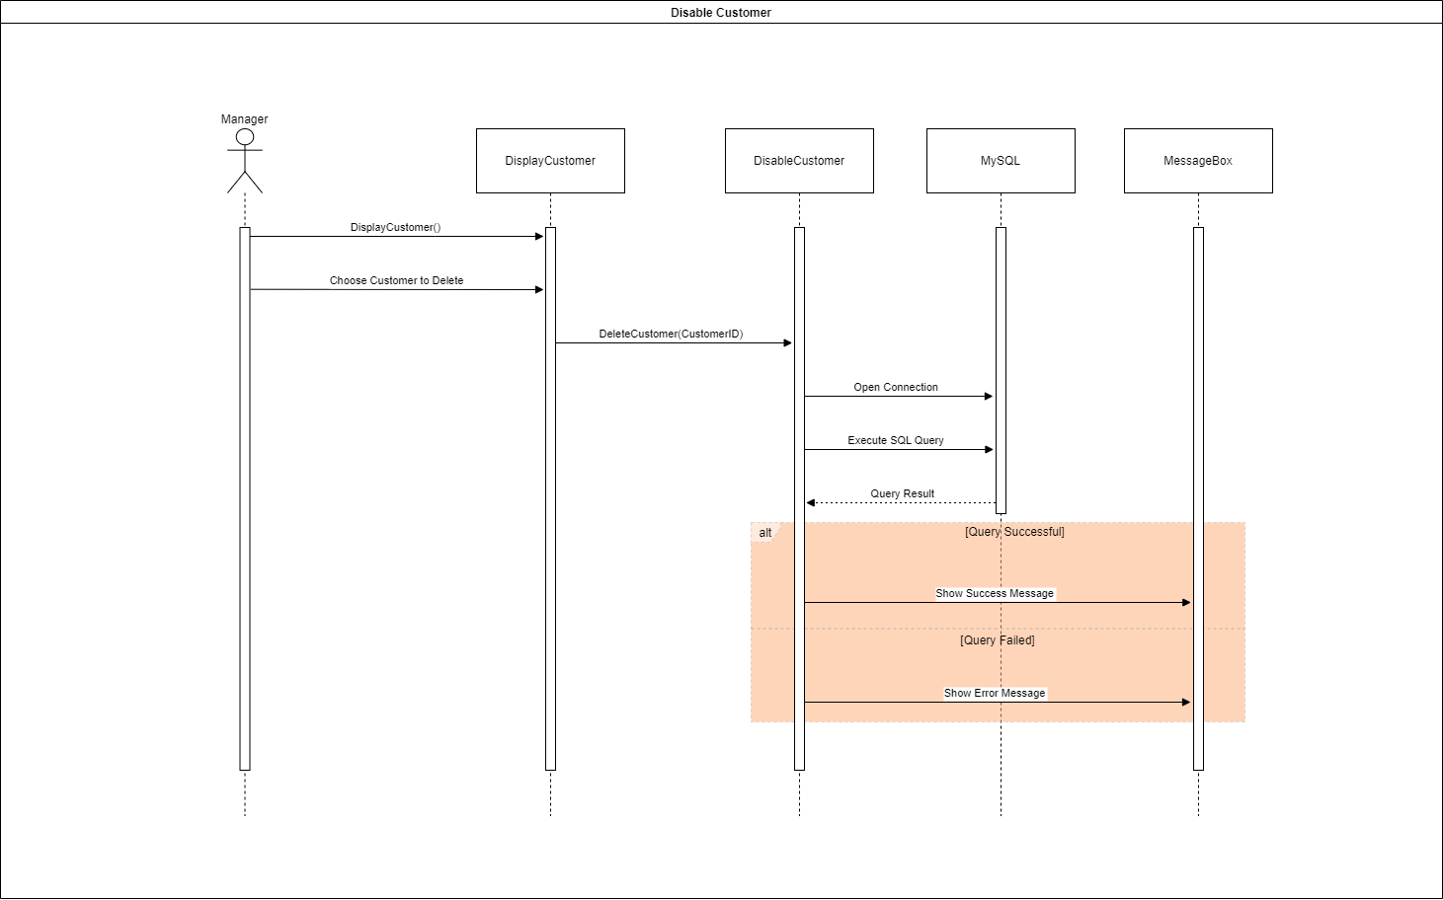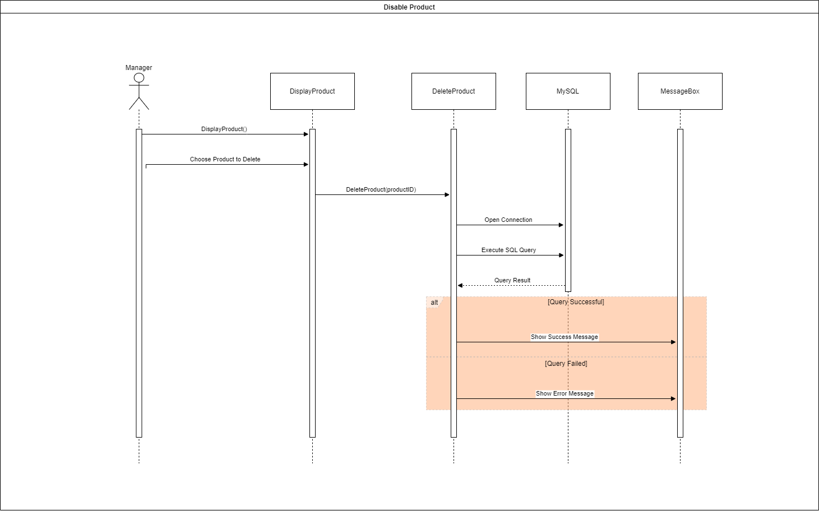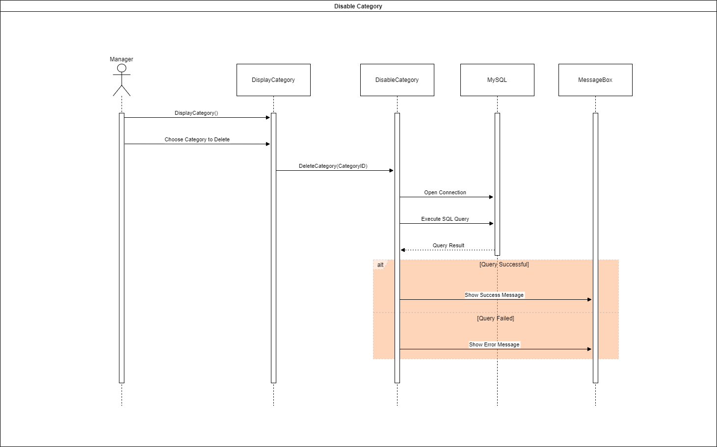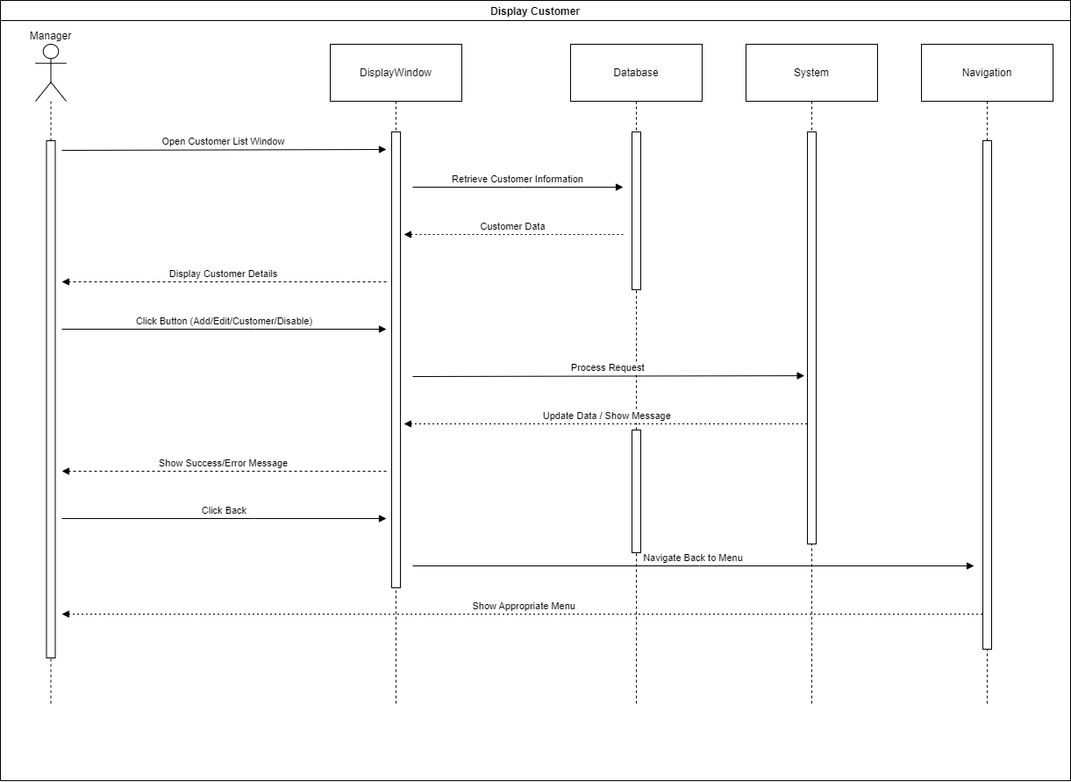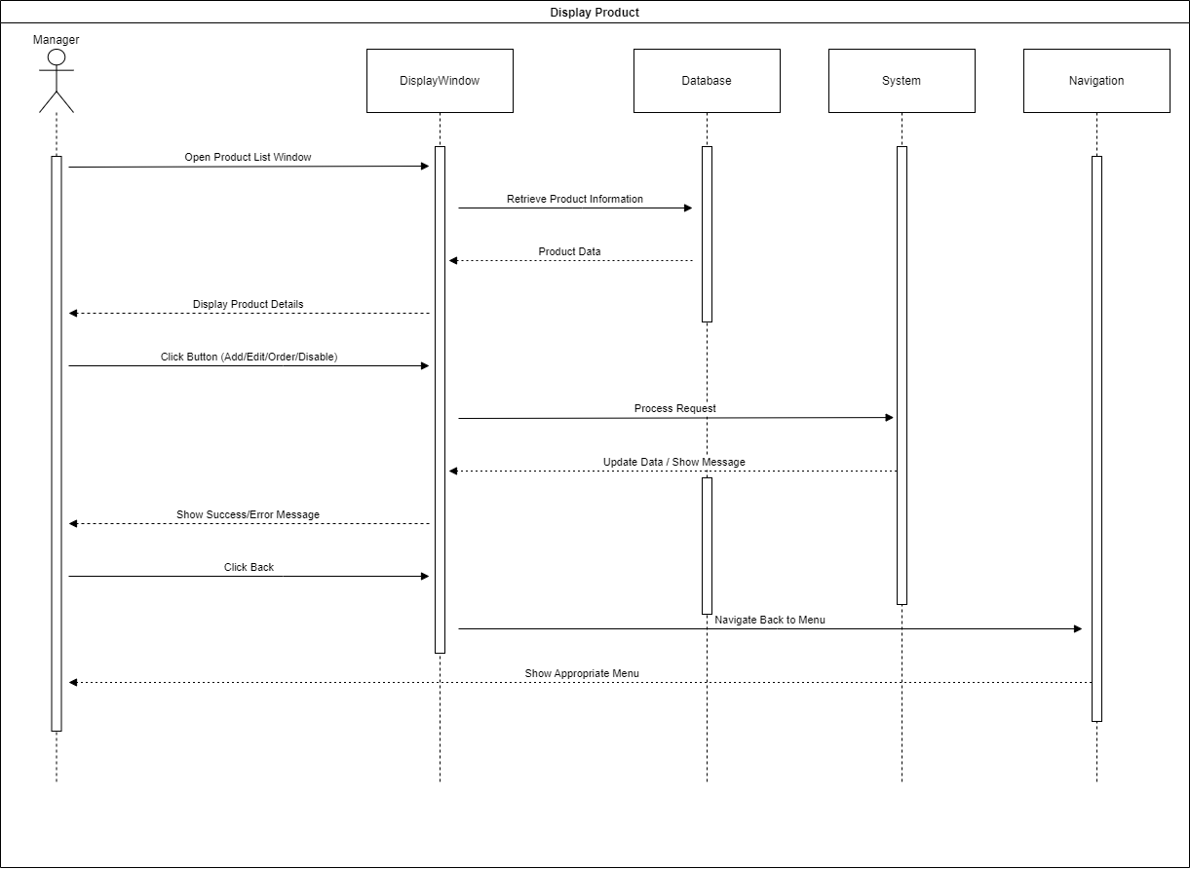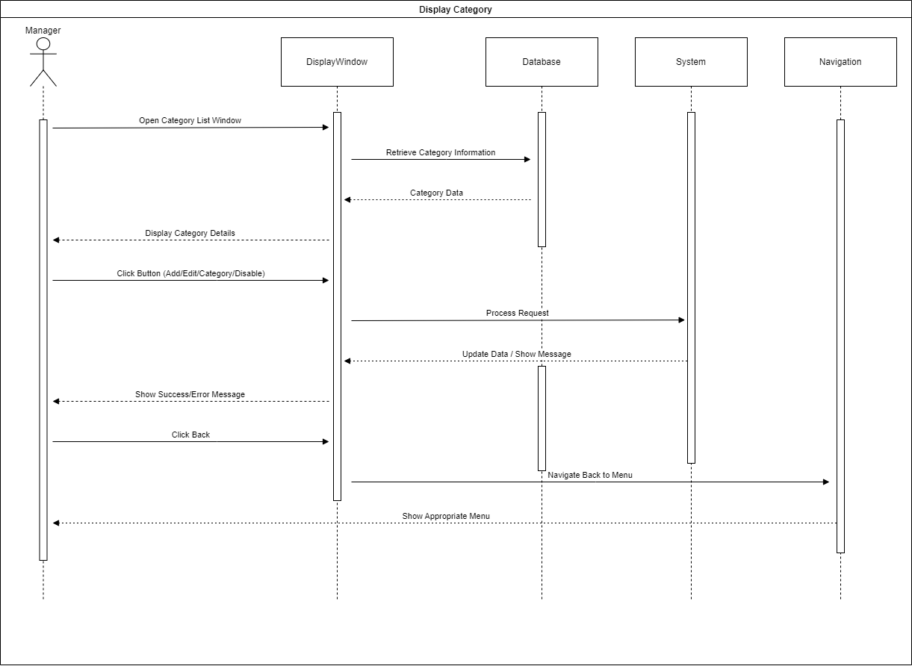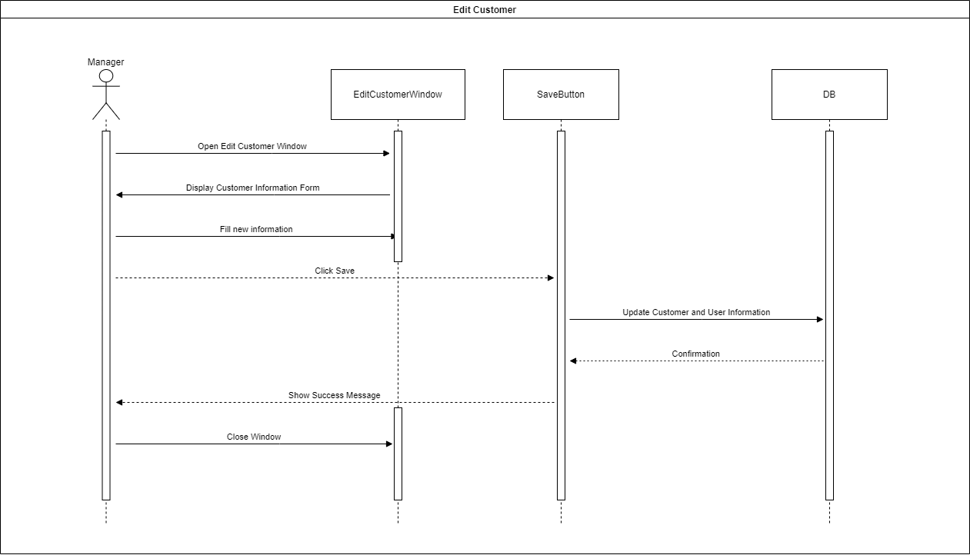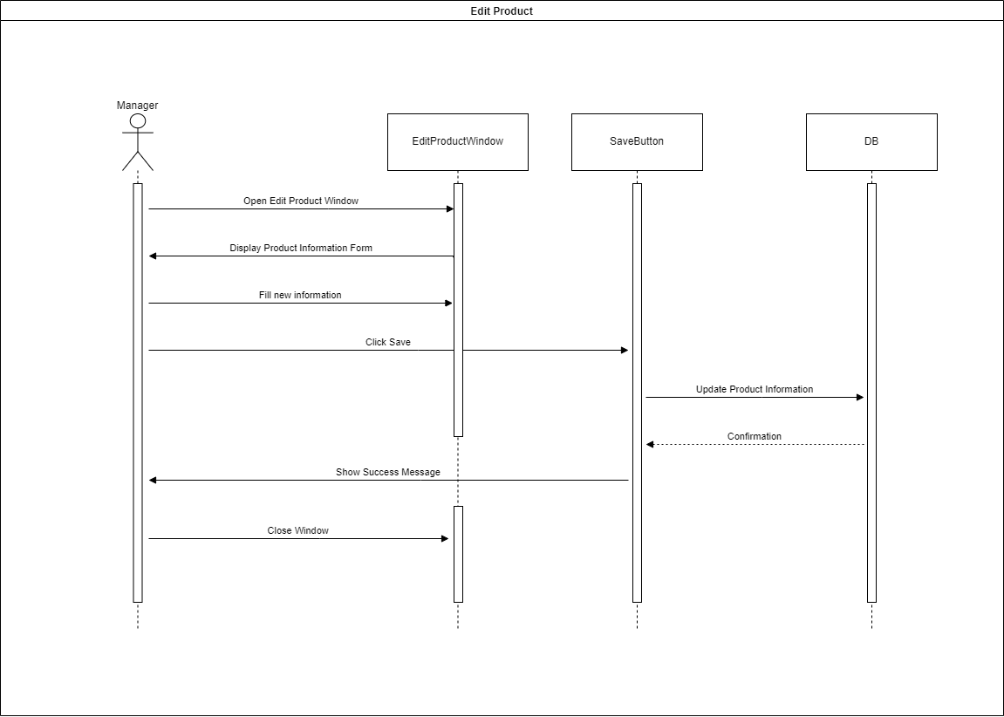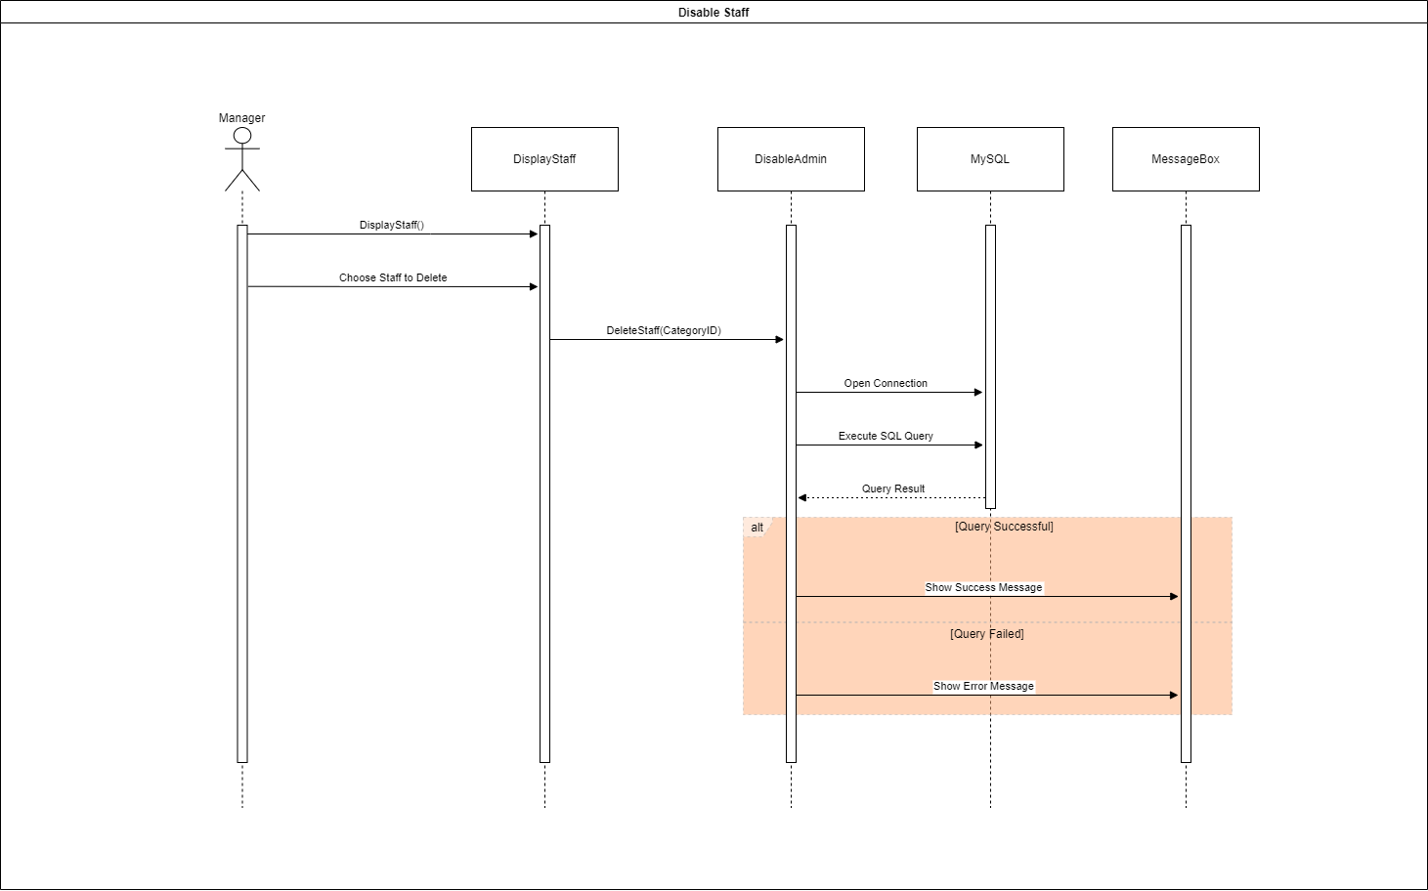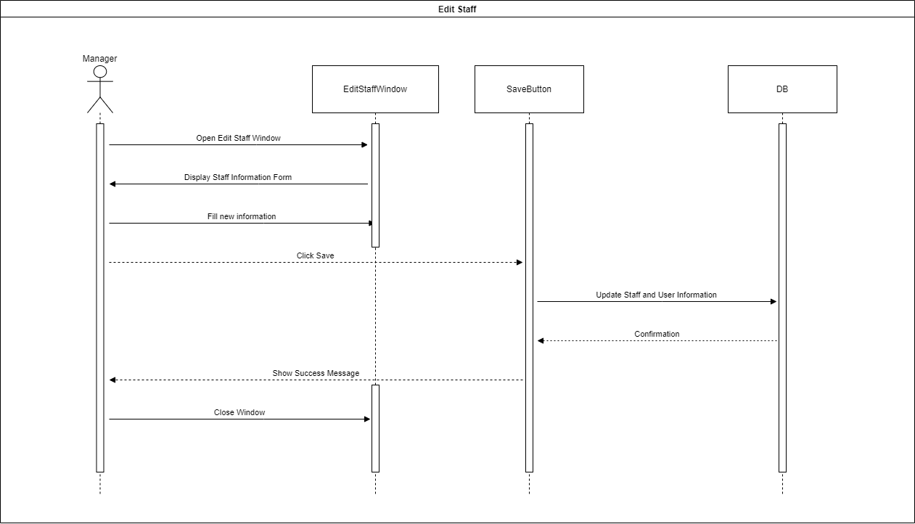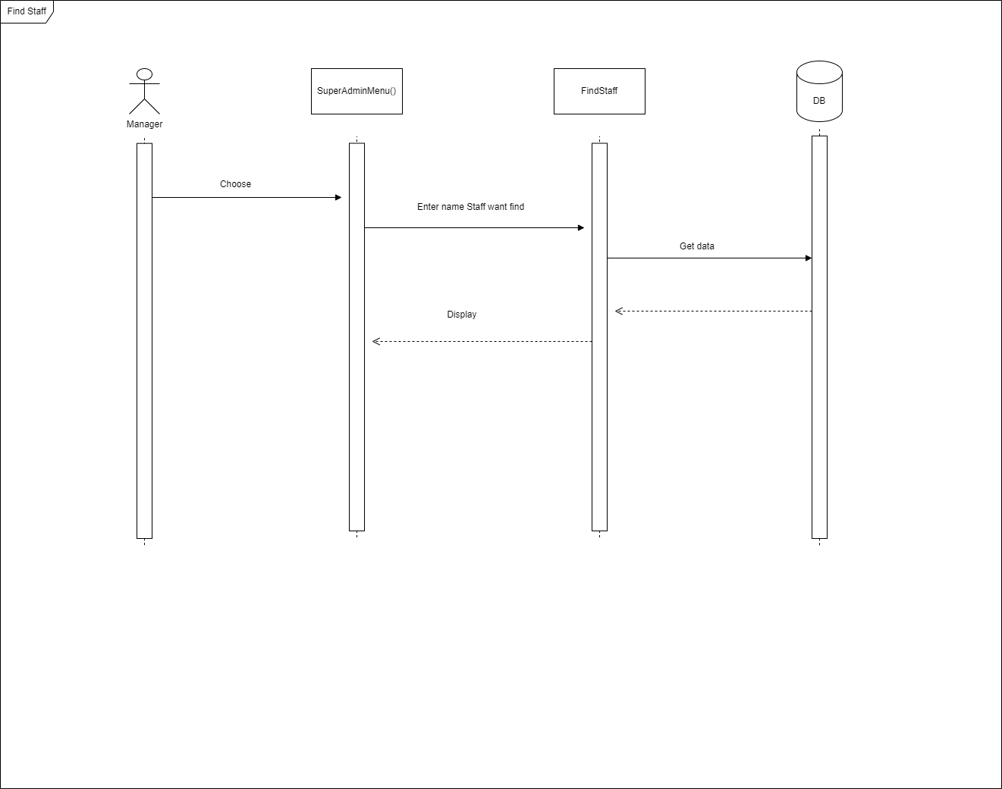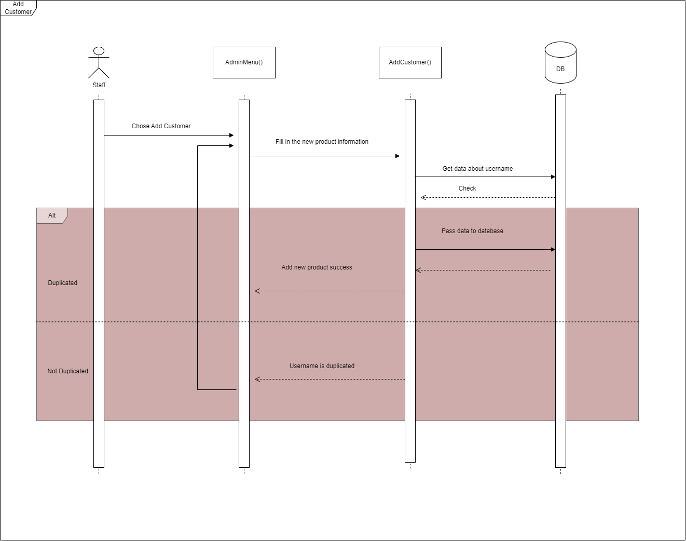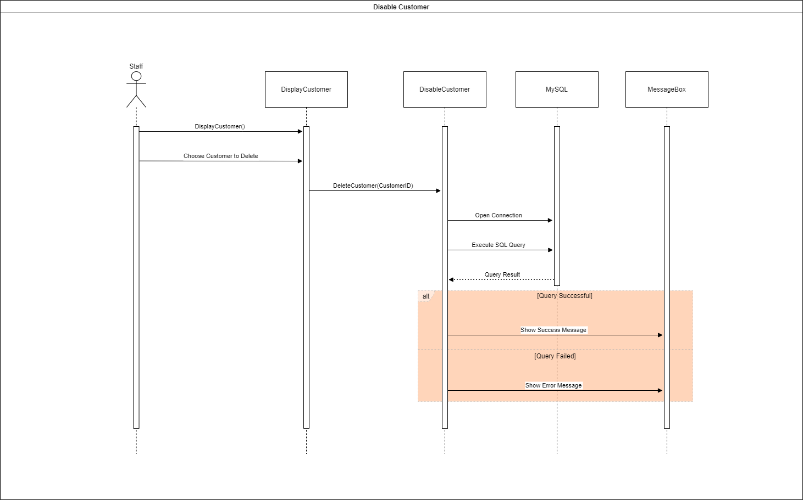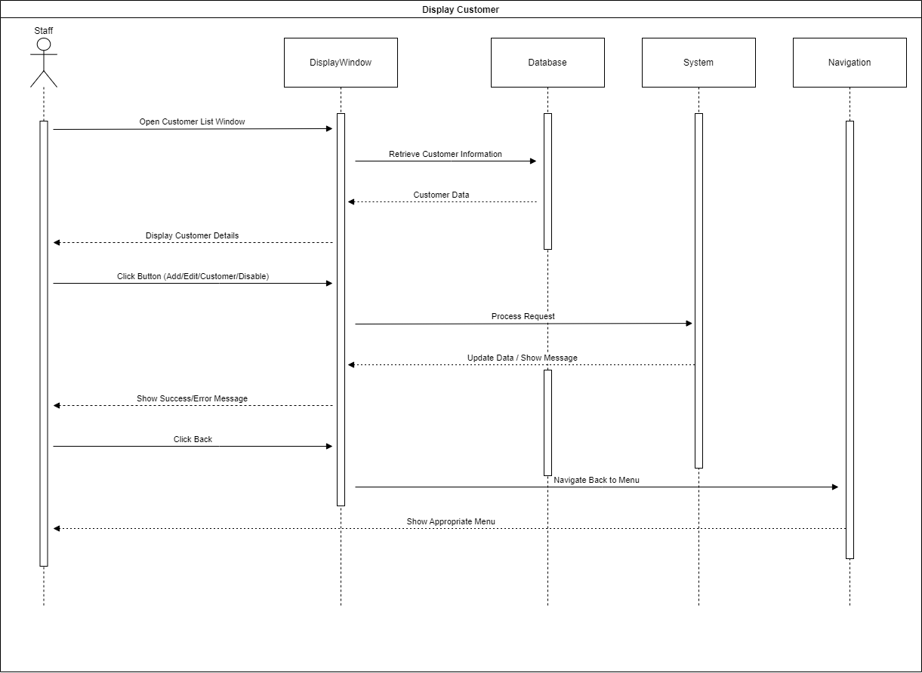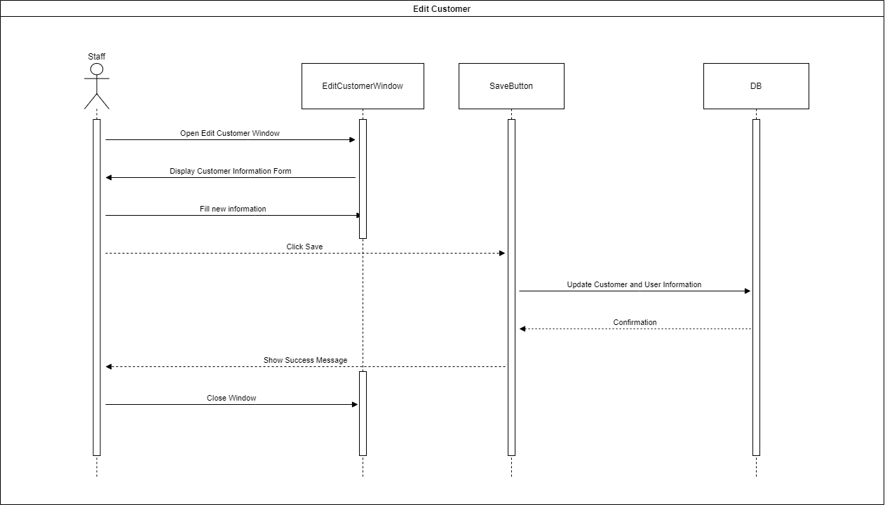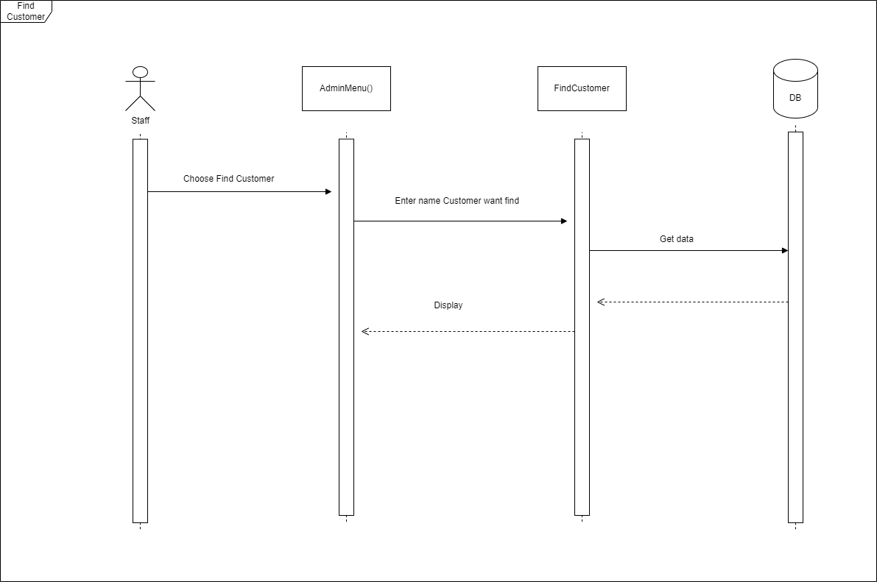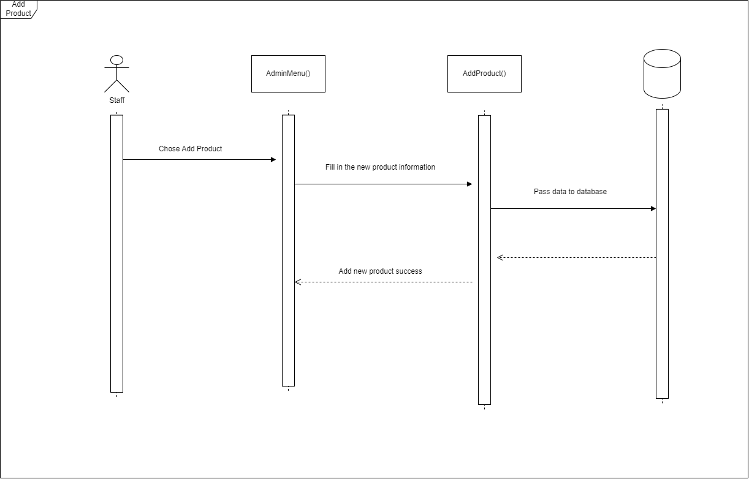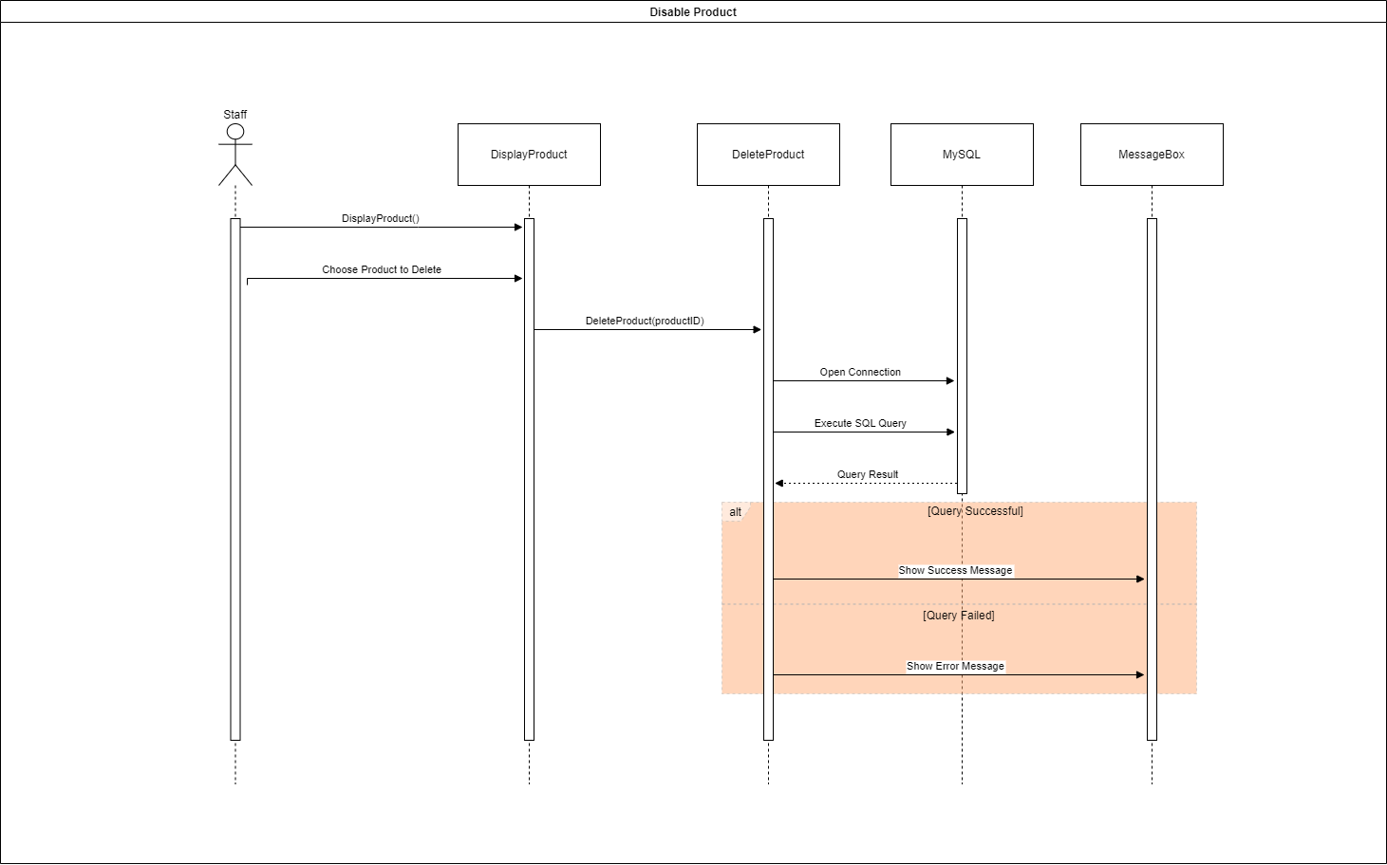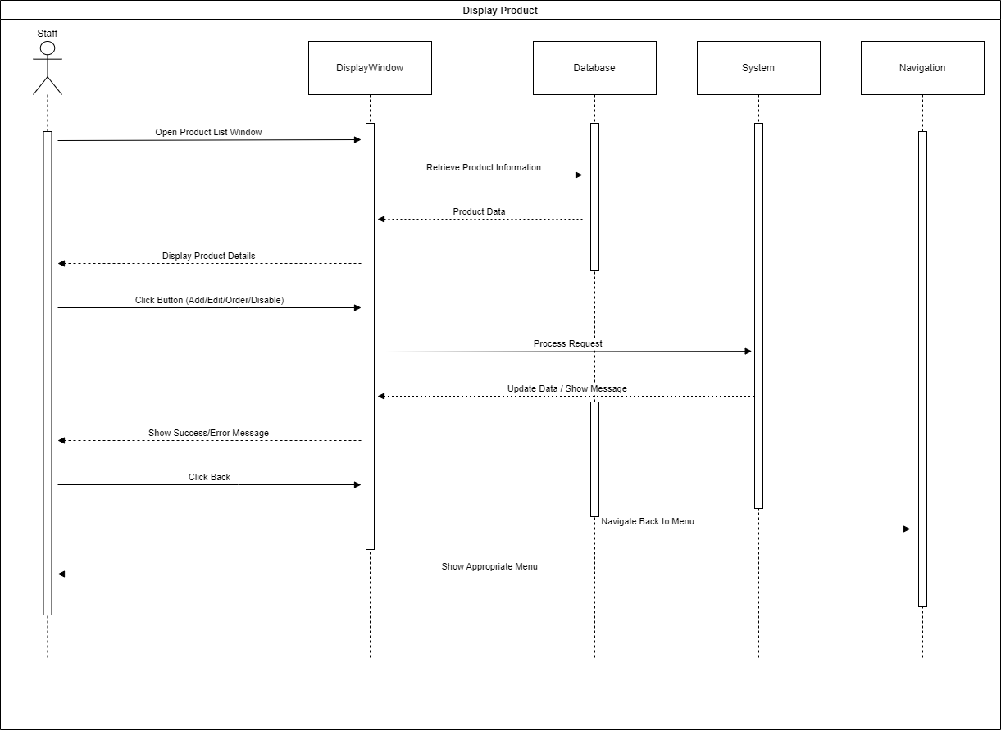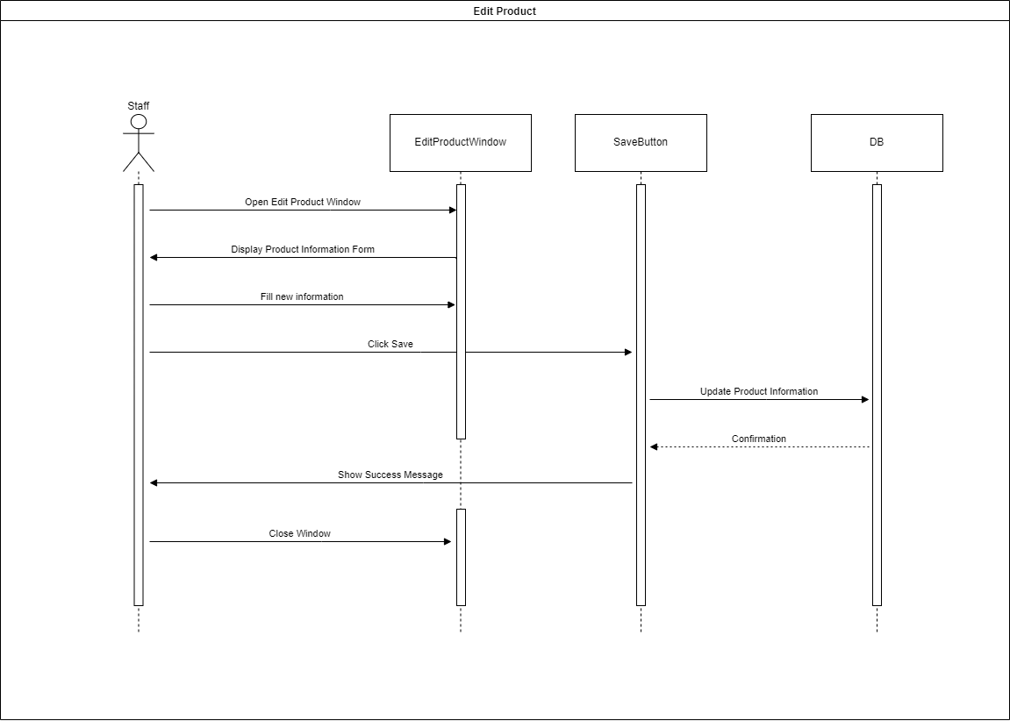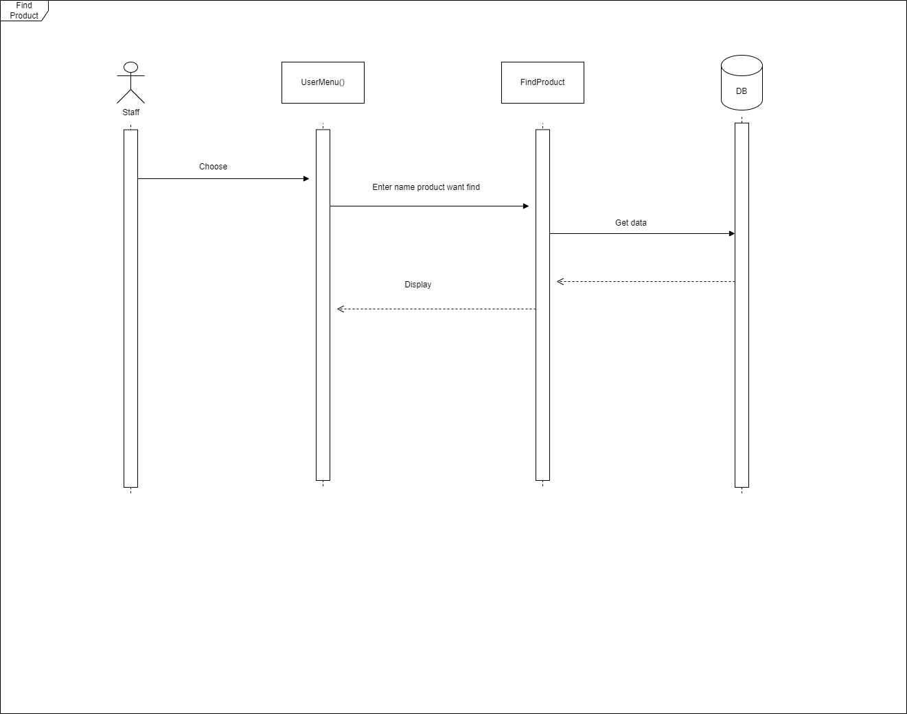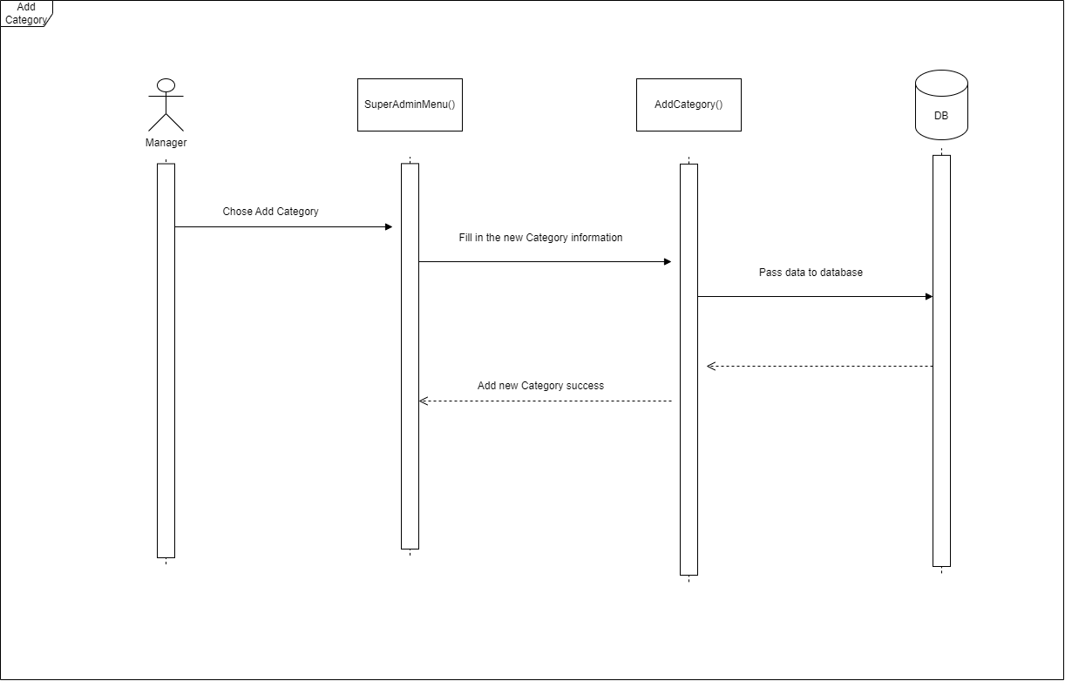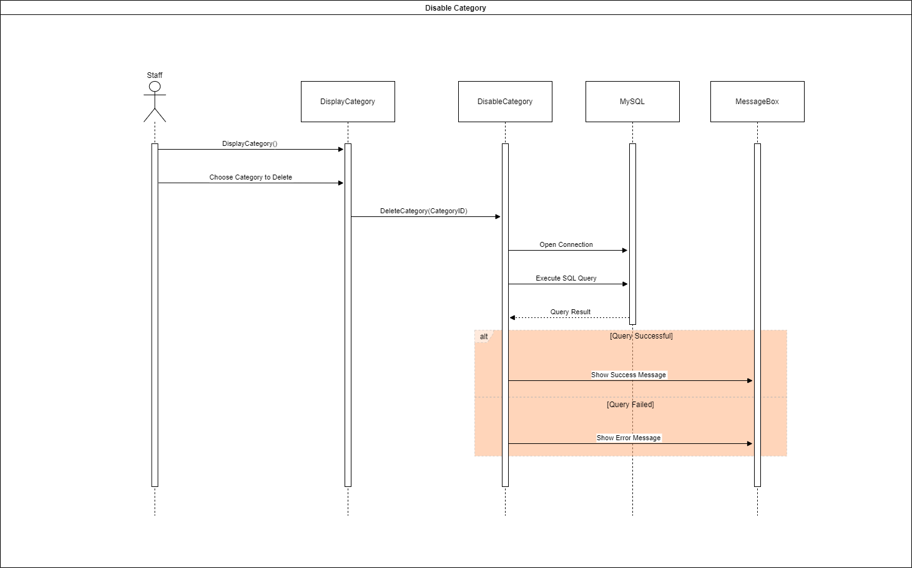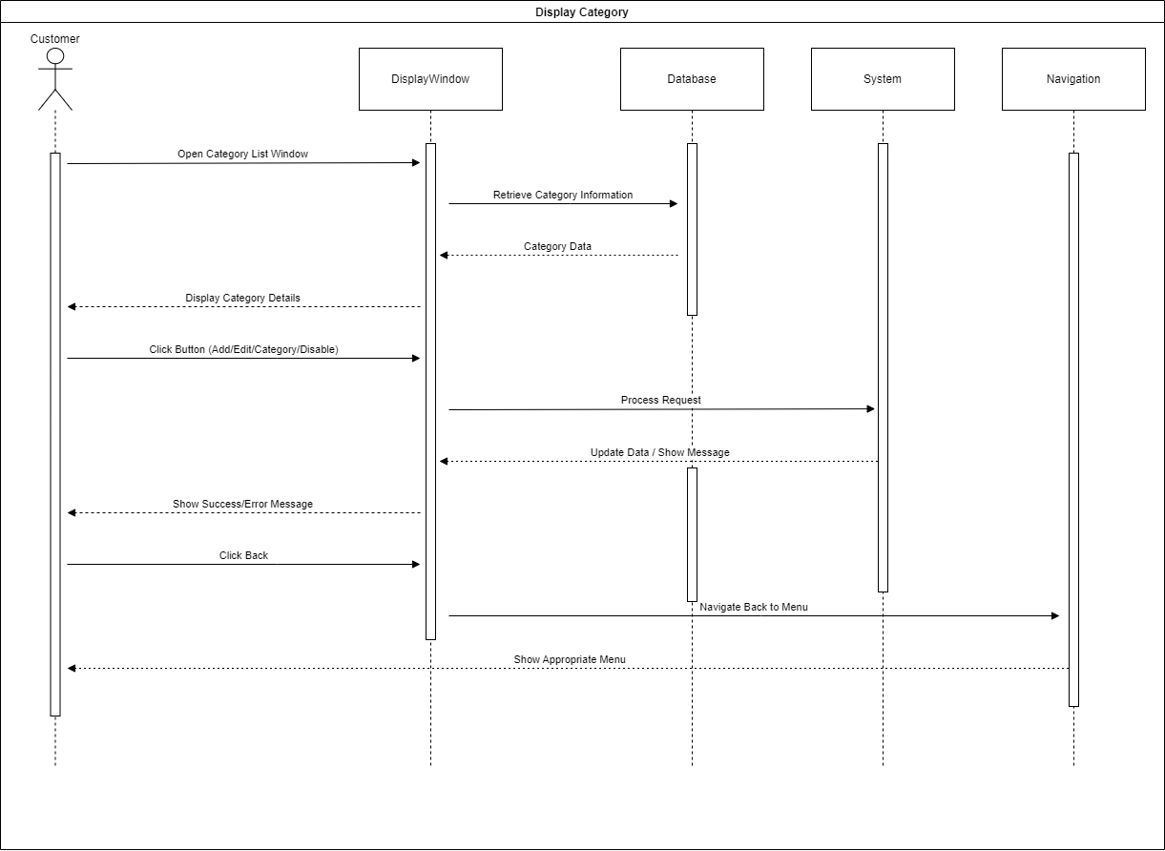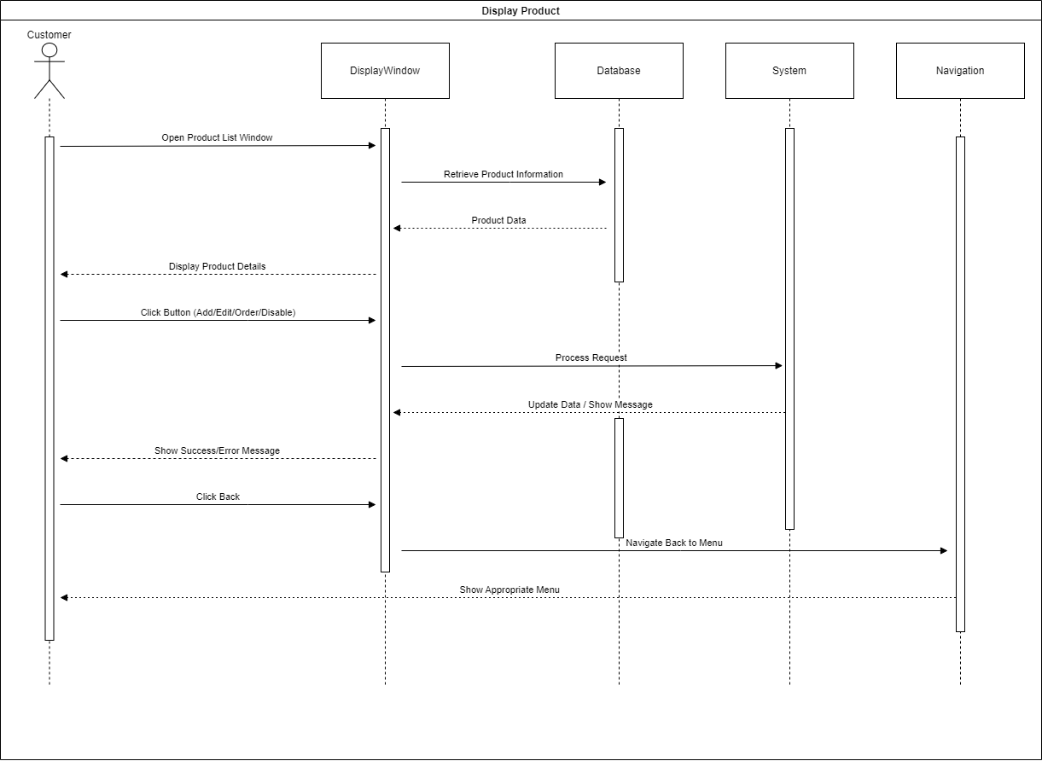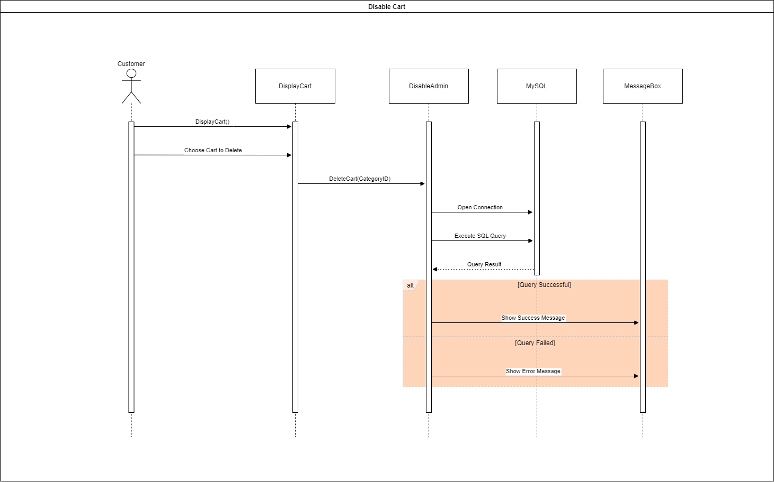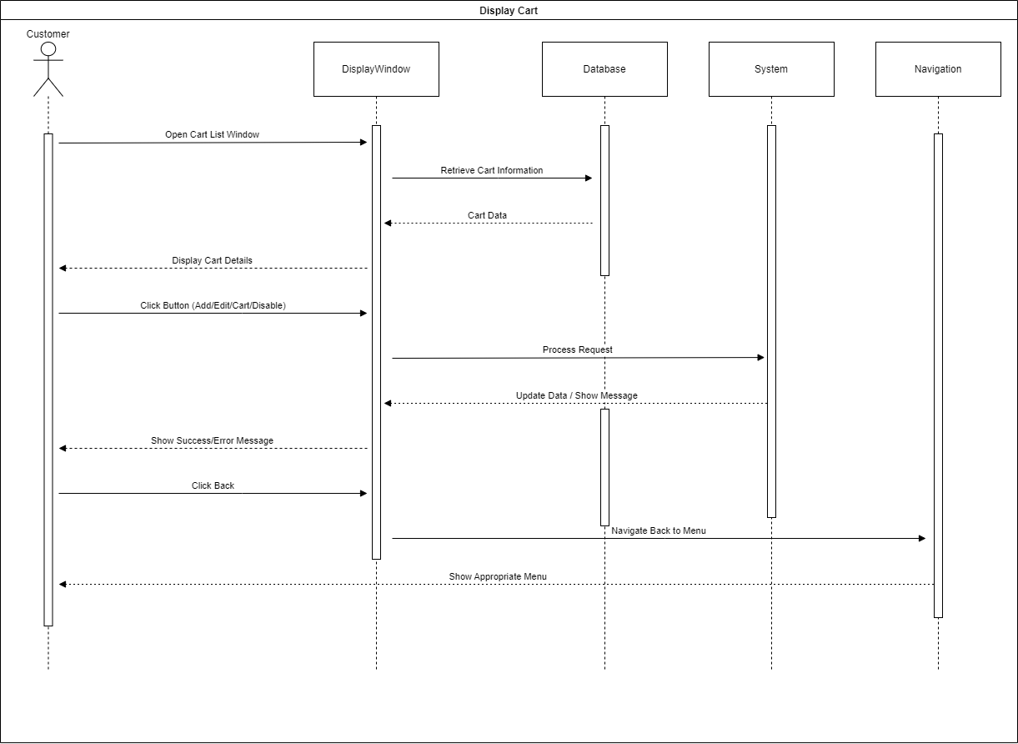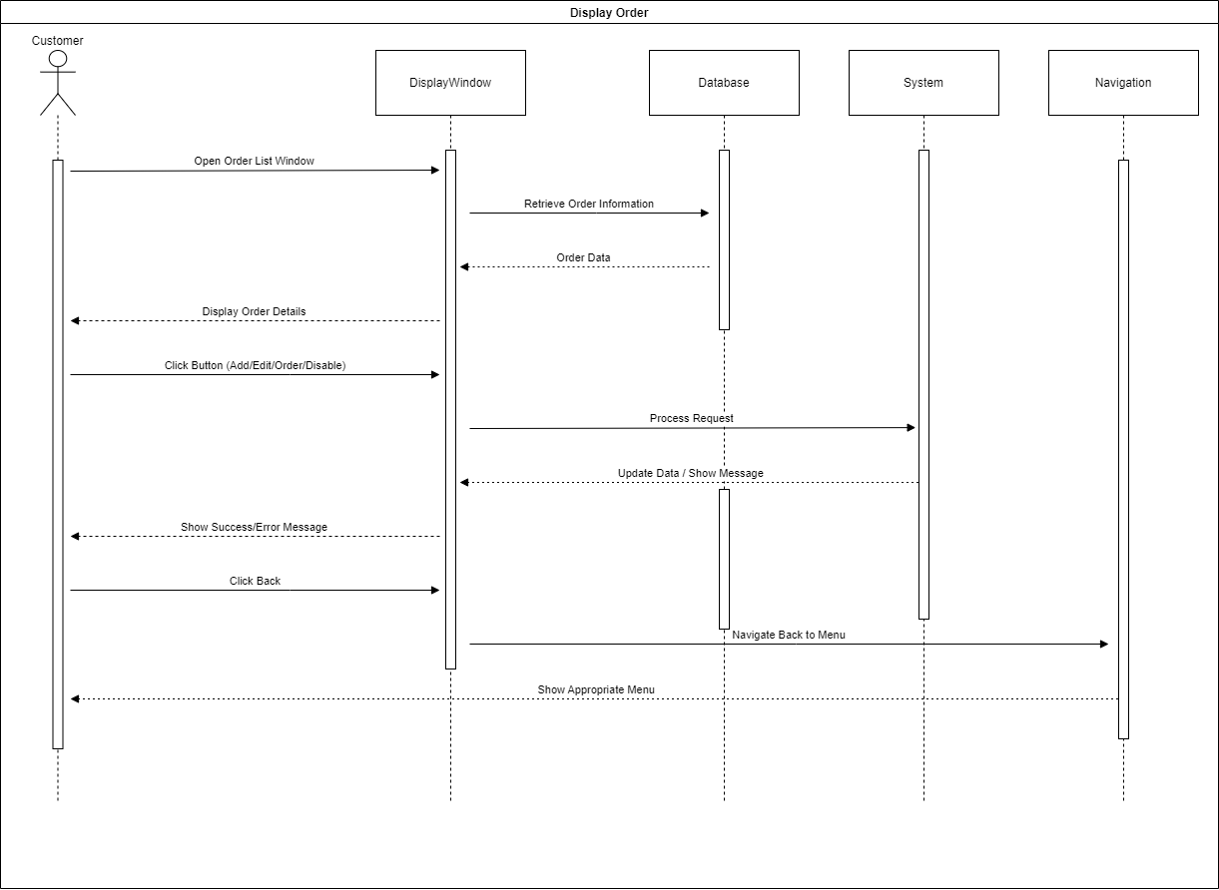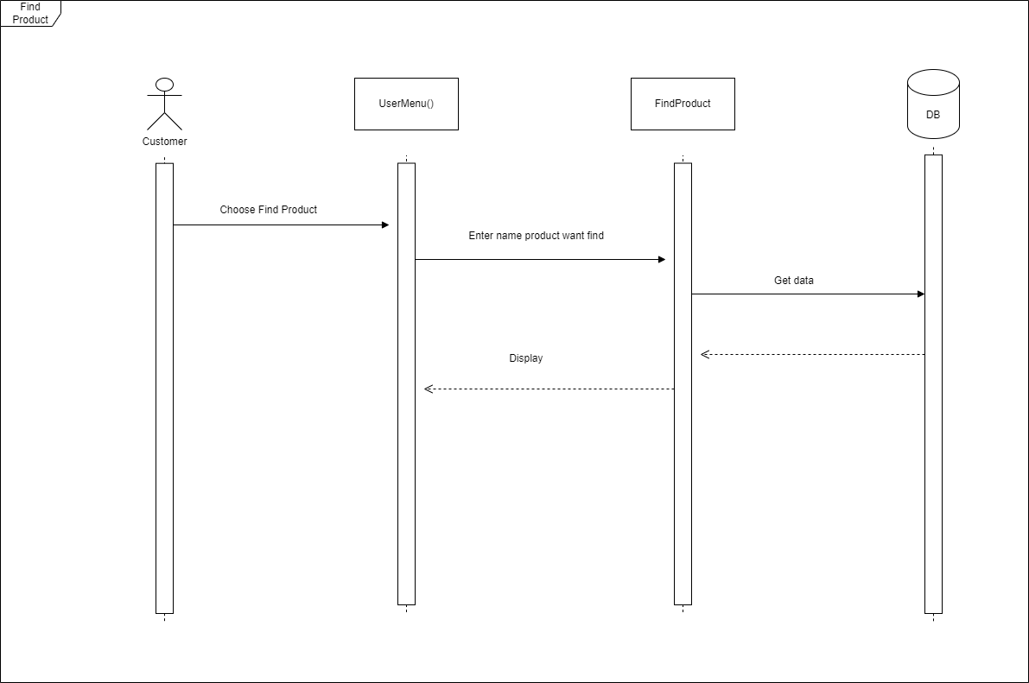

- Database Design
  - Entity Relationship Diagram

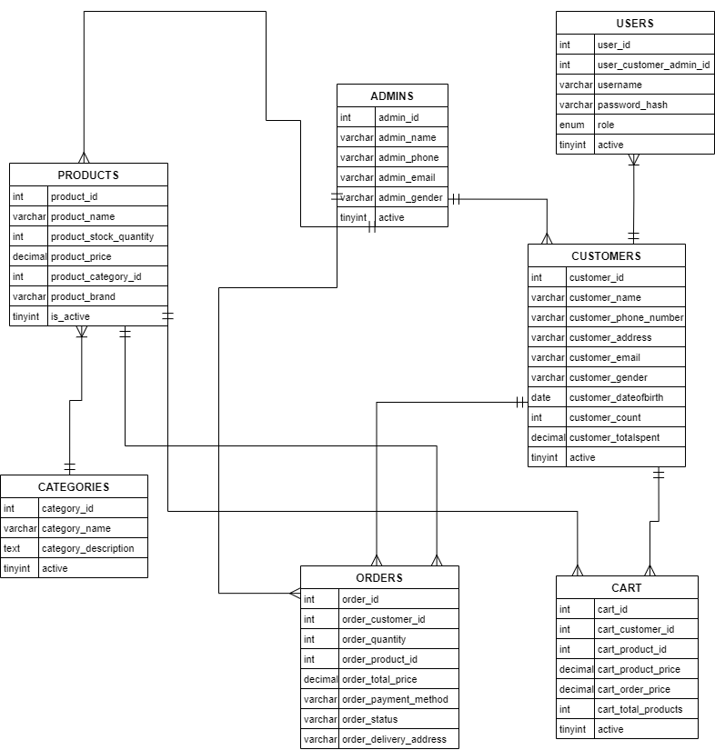

  - Database Design Details
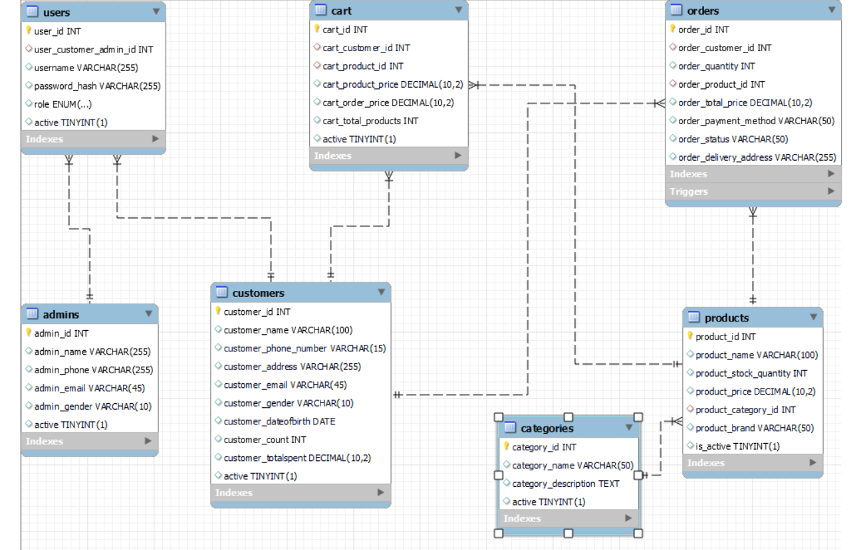
users
Column Name | Data Type | Constraints | Description
user_id | INT | PRIMARY KEY,  NOT NULL,  AUTO INCREMENTAL
user_customer_id | INT | FOREIGN KEY
username | VARCHAR(255) | UNIQUE INDEX
password_hash | VARCHAR(255)
role | ENUM(user, admin, superadmin)
active | TINYINT(1) |  | 1

products
Column Name | Data Type | Constraints | Description
product_id | INT | PRIMARY KEY,  NOT NULL,  AUTO INCREMENTAL
product_name | VARCHAR(100)
product_stock_quantity | INT
product_price | DEMICAL(10,2)
product_category_id | INT | FOREIGN KEY | Connect to category_id in table categories
product_brand | VARCHAR(255)
is_active | TINYINT(1) |  | 1

orders
Column Name | Data Type | Constraints | Description
order_id | INT | PRIMARY KEY,  NOT NULL,  AUTO INCREMENTAL
order_customer_id | INT | FOREIGN KEY | Connect to customer_id in table customers
order_quantity | INT
order_product_id | INT | FOREIGN KEY | Connect to product_id in table products
order_total_price | DEMICAL(10,2)
order_payment_method | VARCHAR(50)
order_status | VARCHAR(50)
order_delivery_address | VARCHAR(255)

customers
Column Name | Data Type | Constraints | Description
customer_id | INT | PRIMARY KEY,  NOT NULL,  AUTO INCREMENTAL
customer_name | VARCHAR(100)
customer_phone_number | VARCHAR(15) | UNIQUE INDEX
customer_address | VARCHAR(255)
customer_email | VARCHAR(45) | UNIQUE INDEX
customer_gender | VARCHAR(10)
customer_dateofbirth | DATE
customer_count | INT |  | 0
customer_totalspent | DEMICAL(10,2) |  | 0.00
active | TINYINT(1) |  | 1

categories
Column Name | Data Type | Constraints | Description
category_id | INT | PRIMARY KEY,  NOT NULL,  AUTO INCREMENTAL
category_name | VARCHAR(50)
category_description | TEXT
active | TINYINT(1) |  | 1

cart
Column Name | Data Type | Constraints | Description
cart_id | INT | PRIMARY KEY,  NOT NULL,  AUTO INCREMENTAL
cart_customer_id | INT | FOREIGN KEY | Connect to customer_id in table customers
cart_product_id | INT | FOREIGN KEY | Connect to product_id in table products
cart_order_id | INT | FOREIGN KEY | Connect to order_id in table orders
cart_product_price | DEMICAL(10,2)
cart_order_price | DEMICAL(10,2)
cart_total_products | INT
active | TINYINT(1) |  | 1

Test
- Login
Test Case Number | 001
Test Case Name | Login()
Test Case Description | Verify successful login with valid credentials
Preconditions | User has valid credentials in DB
Test Case Input | “lolo”, “koko”.  “admin1”, “admin456”.  “superadmin”, “superadmin123”.
Test Case Expected Output | Displays welcome message and navigates to the appropriate menu
Test Case Steps | 1. Launch the application  2. Enter valid username and password  3. Click "Login" button  4. Verify the welcome message and redirection to the correct menu
Default Value Preverving | Yes

- Register
Test Case Number | 002
Test Case Name | Register()
Test Case Description | Verify successful registration with valid inputs
Preconditions | All fields are empty
Test Case Input | newuser , P@ssw0rd, John Doe , 1234567890, 123 Elm Street, john.doe@example.com, Male, 01-01-2000
Test Case Expected Output | Displays "Registration successful!" message and returns to login screen
Test Case Steps | 1. Launch the application  2. Fill in all fields with valid data  3. Click "Register" button  4. Verify success message and redirection to login screen
Default Value Preverving | Yes

- Display product
Test Case Number | 003
Test Case Name | DisplayProduct()
Test Case Description | Verify product list display and button visibility for user role
Preconditions | User is logged in as a user
Test Case Input | Role: user
Test Case Expected Output | Displays products with "Add to Cart" and "Order" buttons; "Edit", "Disable", "Order For Customer" hidden
Test Case Steps | 1. Launch the application  2. Log in as a user  3. Navigate to product display  4. Verify product list and button visibility
Default Value Preverving | Yes

- Add product
Test Case Number | 004
Test Case Name | AddProduct()
Test Case Description | Verify adding a product with valid inputs
Preconditions | User is logged in as admin
Test Case Input | Sample Product, 100, 1, 29.99, Sample Brand
Test Case Expected Output | Product is successfully added; success message shown; redirected to admin menu
Test Case Steps | 1. Launch the application  2. Log in as admin  3. Navigate to add product form  4. Fill in all fields with valid data  5. Click "Save" button  6. Verify success message and redirection to admin menu
Default Value Preverving | Yes

- Edit product
Test Case Number | 005
Test Case Name | EditProduct()
Test Case Description | Verify updating product information with valid inputs
Preconditions | User is logged in as admin
Test Case Input | 1, Updated Product, 150, 19.99, 2, Updated Brand
Test Case Expected Output | Product information is successfully updated; success message shown; redirected to product list
Test Case Steps | 1. Launch the application  2. Log in as admin  3. Navigate to edit product form  4. Enter valid data for all fields  5. Click "Save" button  6. Verify success message and redirection to product list
Default Value Preverving | Yes

- Disable Product
Test Case Number | 006
Test Case Name | EditProduct()
Test Case Description | Verify that a product is marked as inactive successfully
Preconditions | User is logged in as admin
Test Case Input | 1, Updated Product, 150, 19.99, 2, Updated Brand
Test Case Expected Output | 1
Test Case Steps | 1. Launch the application  2. Log in as admin  3. Call DeleteProduct(1)  4. Verify success message
Default Value Preverving | Yes

- Find product
Test Case Number | 007
Test Case Name | FindProduct()
Test Case Description | Verify that a product is marked as inactive successfully
Preconditions | User is logged in as admin
Test Case Input | 1, Updated Product, 150, 19.99, 2, Updated Brand
Test Case Expected Output | 1
Test Case Steps | 1. Launch the application  2. Log in as admin  3. Call DeleteProduct(1)  4. Verify success message
Default Value Preverving | Yes
- Add customer
Test Case Number | 008
Test Case Name | AddCustomer()
Test Case Description | Verify that a product is marked as inactive successfully
Preconditions | Application is running and accessible.  Database is connected and tables users and customers exist.
Test Case Input | Testuser, password123, John Doe, 123-456-7890, 123 Elm Street, john.doe@example.com, Male, 01-01-1990
Test Case Expected Output | - UI Feedback: Success message "Registration successful!" and navigation to admin menu.  - Database: New entries in customers and users tables with correct data.
Test Case Steps | - Open registration form.  - Fill in fields with input values.  - Click "Register" button.  - Verify success message and UI navigation.  - Check database for new entries.
Default Value Preverving

- Edit Customer
Test Case Number | 009
Test Case Name | EditCustomer()
Test Case Description | Verifies the EditCustomer method for correct customer and user data editing, validation, database update, and UI interactions.
Preconditions | Application is running and accessible.  Database is connected and contains customer and user data with the provided customerID.
Test Case Input | Admin, 1, Jane Doe, 098-765-4321, 456 Oak Street, jane.doe@example.com, Female, 02-02-1992, janedoe, newpassword
Test Case Expected Output | - UI Feedback: Success message "Customer information has been updated successfully!" and navigation to customer list.  - Database: Updated entries in customers and users tables with the provided data.
Test Case Steps | - Open the edit customer form with existing data.  - Update fields with new input values.  - Click "Save" button.  - Verify success message and UI navigation.  - Check database for updated entries.
Default Value Preverving

- Disable customer
Test Case Number | 010
Test Case Name | DisableCustomer()
Test Case Description | Tests the DeleteCustomer method for marking a customer as inactive and ensuring proper database update and UI notification.
Preconditions | Application is running and connected to the database.  Customer with the specified customerID exists and is active.
Test Case Input | 1
Test Case Expected Output | - UI Feedback: Success message "Customer successfully marked as inactive!"  - Database: active field in customers and users tables set to FALSE for the specified customerID.
Test Case Steps | - Invoke the DeleteCustomer method with a valid customerID.  - Verify the success message displayed.  - Check the database to ensure the active field is set to FALSE for the customerID in both customers and users tables.
Default Value Preverving

- Display Customer
Test Case Number | 011
Test Case Name | DisplayCustomer()
Test Case Description | Tests the DisplayCustomers method for correctly displaying a list of active customers in a window with their details and action buttons.
Preconditions | Application is running and connected to the database.  The database contains active customers and users with the role 'user'.
Test Case Input | Role: "admin" or "superadmin"
Test Case Expected Output | - UI: A window listing customers with:  - Customer details: Name, Phone, Address, Email, Gender, Date of Birth, Orders, Total Spent, Username, Password  - Buttons for "Edit" and "Delete" for each customer  - A "Back" button to navigate to the previous menu  - Database: Customers with active = TRUE and users with role = 'user' should be displayed.
Test Case Steps | - Invoke the DisplayCustomers method with a valid role.  - Verify the display window appears with the customer list.  - Check each customer's details and action buttons are correctly displayed.  - Click on "Edit" and ensure it opens the edit customer window with pre-filled details.  - Click on "Delete", confirm deletion, and ensure the customer is marked as inactive.  - Click "Back" and ensure it navigates to the appropriate menu based on the role.
Default Value Preverving

- Find Customer
Test Case Number | 012
Test Case Name | FindCustomer()
Test Case Description | Tests the FindCustomer method for its ability to search and display customer details based on the input name.
Preconditions | Application is running and connected to the database.  The database contains customers and users with the role 'user'.
Test Case Input | Role: "admin" or "superadmin"  Customer Name: A valid customer name or partial name for searching.
Test Case Expected Output | - UI: A window with:  - A text field for entering the customer name.  - A "Find" button to initiate the search.  - A "Close" button to close the search window.  - If Customer is Found:  - A new window with a list of customers matching the search term, displaying:  - Customer details: Name, Phone, Address, Email, Gender, Date of Birth, Orders Count, Total Spent, Username, Password  - A "Close" button to close this window.  - If No Customer is Found:  - An error message indicating that no customer was found.
Test Case Steps | Open Find Customer Window  Search for a Customer  Verify Search Results  Close the Find Customer Window
Default Value Preverving

- Add Staff
Test Case Number | 013
Test Case Name | AddStaff()
Test Case Description | Tests the AddStaff method to ensure it correctly registers a new staff member and handles input validation, database interactions, and UI updates.
Preconditions | Application is running and connected to the database.  Database schema includes users and admins tables with appropriate fields.
Test Case Input | 1, ,1, 1 ,1 , 1, 1
Test Case Expected Output | - Success message.  - Validation Errors  - Database Errors
Test Case Steps | - Open Add Staff Window  - Register New Staff  - Close the Window
Default Value Preverving

- Find Staff
Test Case Number | 014
Test Case Name | FindStaff()
Test Case Description | Verify that the FindStaff method correctly searches for staff members and displays the results in a new window. Ensure that invalid inputs and errors are handled properly.
Preconditions | The application is running and connected to the database
Test Case Input | 1
Test Case Expected Output | Valid Input  Invalid Input  No Matching Staff
Test Case Steps | - Fill name want find  - Click find button
Default Value Preverving

- Display Staff
Test Case Number | 015
Test Case Name | DisplayStaff()
Test Case Description | Verify that the DisplayStaff method successfully displays a list of staff members in a new window, with appropriate staff details, and handles user interactions for editing and deleting staff records.
Preconditions | - The application is running and connected to the database.  - Staff data exists in the admins and users tables.
Test Case Input
Test Case Expected Output | Staf Display  Edit button  Delete button
Test Case Steps
Default Value Preverving

- Edit Staff
Test Case Number | 016
Test Case Name | EditStaff()
Test Case Description | Verify that the EditStaff method correctly displays an editable window with staff details, allows modifications, and updates the database with new information upon saving
Preconditions | The application is running and connected to the database.
Test Case Input | 1, 1, 1, 1, 1, 1, 1
Test Case Expected Output | Edit button, Save button, Close button, Error handling
Test Case Steps | - Modify Staff Details  - Verify Update Functionality  - Test Save Without Changes
Default Value Preverving

- Order product
Test Case Number | 017
Test Case Name | OrderProduct()
Test Case Description | Verify that the PlaceOrderDirectly method correctly places an order by inserting it into the database, updating the total price, and handling exceptions
Preconditions | The application is running and connected to the database.
Test Case Input | 1, 1, 1, 1
Test Case Expected Output | - Success Message  - Error Handling  - Database Error  - General Error
Test Case Steps | - Successful Order Placement  - Database Error Handling  - General Error Handling
Default Value Preverving

- Order for customer
Test Case Number | 018
Test Case Name | OrderProduct()
Test Case Description | Verify that the OrderProductForCustomer method correctly handles the ordering process by validating customer information, managing product stock, and placing the order
Preconditions | - The cart and pd objects are initialized and accessible.  - The role parameter is correctly set to either "admin", "superadmin", or "user".
Test Case Input | 1, 1, 1, 1, 1
Test Case Expected Output | - Success Message  - Error Handling
Test Case Steps | - Order Placement with Valid Data  - Field Validation  - Cancellation
Default Value Preverving

- Update Status
Test Case Number | 019
Test Case Name | UpdateStatus
Test Case Description | Verify that the UpdateStatus method correctly initializes and displays the user interface for updating the status of an order.
Preconditions | The application is running and connected to the database.
Test Case Input | 1
Test Case Expected Output | - Success Message  - Error Handling  - Invalid Order ID  - Cancellation
Test Case Steps | - Interface Initialization  - Update Status Functionality  - Closing the Window  - Cancelling the Close Operation
Default Value Preverving

- Add category
Test Case Number | 020
Test Case Name | AddCategory()
Test Case Description | Verify that the AddCategory method correctly initializes and displays the user interface for adding a new category
Preconditions | The application is running and connected to the database.
Test Case Input | 1, 1
Test Case Expected Output
Test Case Steps | - Interface Initialization  - Saving Category  - Handling Database Errors
Default Value Preverving
- Disable category
Test Case Number | 021
Test Case Name | DisableCategory()
Test Case Description | Verify that the DeleteCategory method correctly marks a category and its associated products as inactive in the database
Preconditions | The application is running and connected to the database.
Test Case Input | 1
Test Case Expected Output
Test Case Steps
Default Value Preverving | - Ensure that no unintended records are modified if the CategoryID is not found.  - Ensure that the application continues to function normally after the method execution.

- Display category
Test Case Number | 022
Test Case Name | DisableCategory()
Test Case Description | Verify that the DisplayCategories method displays categories correctly based on the user role and provides appropriate functionality for each role
Preconditions | The application is running and connected to the database.
Test Case Input | Role: The role of the current user (e.g., "user" or "superadmin").
Test Case Expected Output
Test Case Steps
Default Value Preverving | - Ensure that no unintended changes are made to the database.  - Verify that the application continues to function normally after navigating back to the menu.

Task Assign (to each team member)
HCL | HCL Electronic Shop
No | Task name | Description | Start Date | End Date | Member | Self assessment
1 | Code logic | Come up with most of the ideas for how the system of the application will work. | May 29th | June 27th | Long
2 | Draw diagram | Drawing flowcharts and the diagrams for the code logic. | May 29th |  | Long, Huy
3 | Code | Write the program. | May 29th | June 27th | Long, Cuong, Huy
4 | Write report | Make the detailed report about the project progression and explain all the functions. | June 28th |  | Long, Cuong, Huy
5 | Slide design | Make power point slides of the report for presentation. | June 28th |  | Cuong, Huy

Installation Instructions
INSTALLATION INSTRUCTIONS FOR HCL APPLICATION
System Requirements:
- Operating System: Windows
- Deployment Diagram
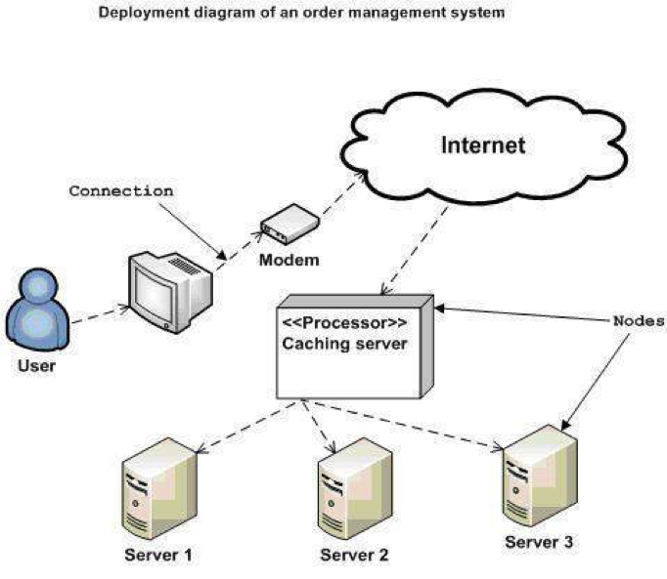
- Installation steps
  - Database Install
    - Download MySQL Community Server from the website:
https://dev.mysql.com/downloads/mysql/
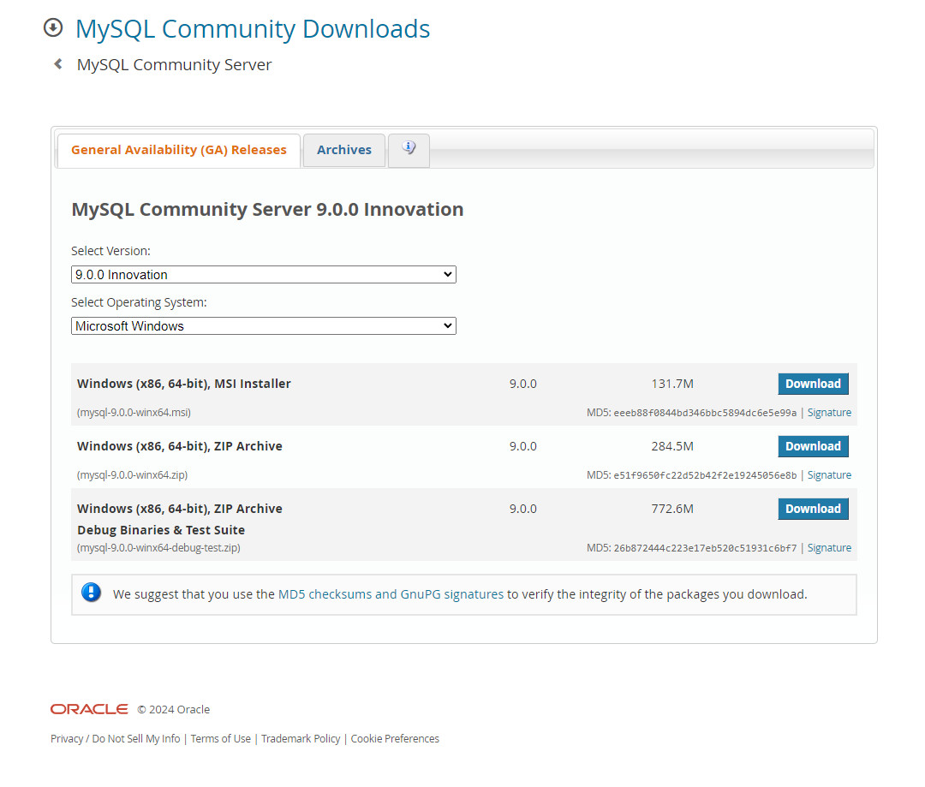
    - Choose the version that’s most suitable for your device and download.
    - Extract the file and run the installation.
    - Adjust the installation options like installation directory, port, root, passwords, etc… to your liking then click “Next”.
    - Finish configuring your MySQL and start the service.
    - Open Command Prompt and run the command: mysql –version to check the currently installed MySQL version.
  - Application install
    - Download the application from this link: GitHub - KingBoyLong2005/shop and click the green < > Code button. Next choose Download ZIP to start downloading the application.
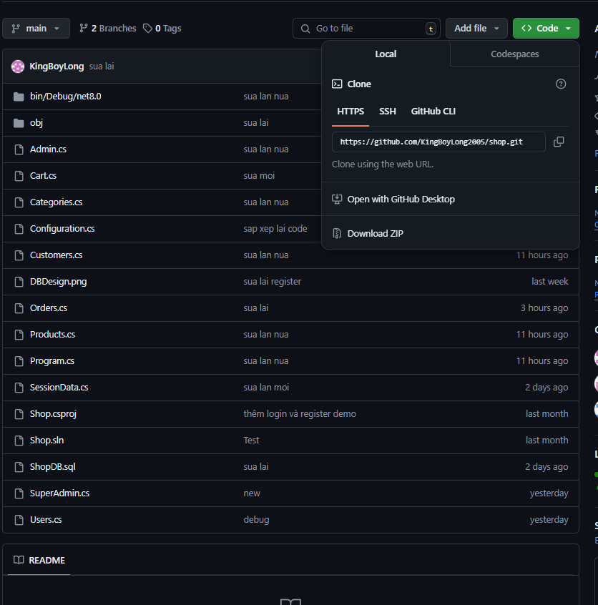
    - Once downloaded, extract the ZIP file to any folder you want then follow the path shop-main/bin/Debug/net8.0. Here find the Shop.exe file, right click and choose move to Desktop.
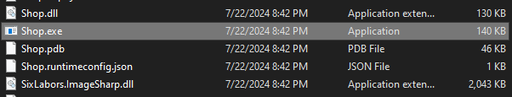
    - Double click the Shop.exe file to run the application, then enter your root password. After that you can enter your application account to start using the application.

Appendix
Terms and abbreviations
Admin – Staff level user’s role
Super Admin – Manager level user’s role
Some other issues
You have to run VSC and use dotnet run for the application file to load.

